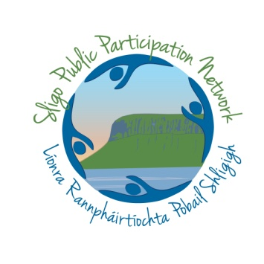
Event Notification Form for promotion by Sligo PPN

Name of submitting Group __________________________________________________________

PPN Membership Number __________________

Location of Group __________________________________________________________________

Outline of your Event (This is your chance to sell the event – what do you want people to know about it – how will you get their attention. Please keep this to one concise paragraph in WORD format)

Event Details – (Time, Date, Location. Also think about where people go to find out more, ie email, phone, website and any dual social media promotion links)

*Don’t forget to attach any associated LOGO and engaging PHOTOS that celebrates the event. Be sure to send the photo and logo through in a format that can easily be uploaded ie jpeg, gif and of course any photos featuring people should be GDPR compliant.

