Briefing Document
2019 Elections

PPN Representation roles on the following committees:
- Sligo Strategic Policy Committees
- Sligo Joint Policing Committee

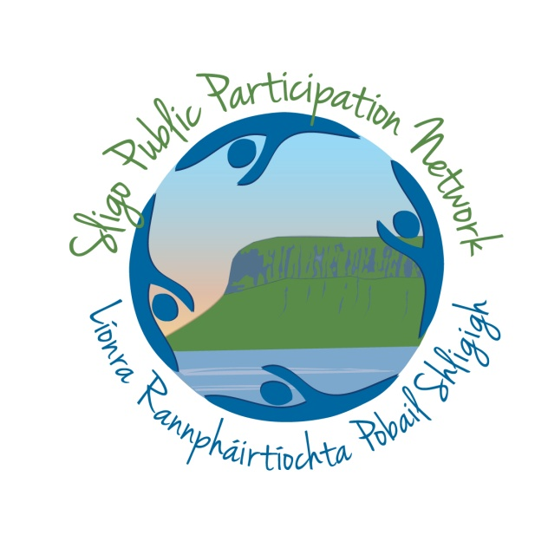

Deadline:
Monday 25th November, 4.30pm

What is the Sligo Public Participation Network?
Sligo Public Participation Network (PPN) is a network of over 350 community groups in the Sligo administrative area. The PPN facilitates participation and enables engagement between local government and communities. PPNs are an initiative of the Department of Rural and Community Development.
What are the Strategic Policy Committees and the Joint Policing Committee
Sligo Strategic Policy Committees
10 Seats Available: 2 Social Inclusion, 4 Environment, 4 Community & Voluntary
SPC’s have a major role in assisting and advising the Council in relation to functions of a strategic, statutory nature. They should meet at least four times annually, and develop a work programme linked to the Council’s Corporate Plan. The role of the Strategic Policy Committees as set out in legislation is to:
- assist the Council in the formulation, development and review of policy
- reflect the major functions or services of a local authority within the broader context

Term Length: Until 2024
Committee Meetings: Minimum 4 per year.
Location: County Council buildings
Induction & Training: Networking and ‘Meet the Reps’ event 12 December 2019.
All successful nominees will be required to participate in a once off induction and training session (date to be confirmed) in January 2020

Commitments
PPN AGM: 1 Per Year. Evening time. Usually in November.
On-going:
- On-going administration and communication between meetings.
- Representing the PPN network at meetings and events
- Undertaking roles on sub-groups of the Secretariat
- Supporting the Resource Worker in the roll out of the PPN annual workplan

Joint Policing Committee (JPC)
6 Seats Available – open call from any college
Joint Policing Committees were introduced under the Garda Síochána Act 2005 as a mechanism for identifying and addressing policing issues where adopting a partnership approach between An Garda Síochána, the Local Authority and the community is desirable to achieve a favourable outcome.

The purpose of these JPC’s is to provide a forum where a Local Authority and the senior Garda officer responsible for the policing of that area, with the participation of Oireachtas members and community interests can consult, discuss and make recommendations on matters affecting the policing of the area. It is intended that the JPC’s will be partnerships which are co-operative in nature and operate with the minimum of formality to identify, raise awareness of and find solutions for issues impacting on, or causing concerns for the local community. Through the work of a JPC both partners - the local authority and the Garda Síochána - along with Oireachtas members and community interests have the opportunity to contribute to the improved safety and quality of life of the community. It is essential that JPC’s take a strategic approach to their work so that issues arising can be dealt with in a considered and properly co-ordinated manner.

Committee Meetings: Minimum 4 per year.
Location: Morning meetings. Meetings rotate around the 3 Municipal District areas
Induction & Training- Initial meeting with JPC Coordinator, PPN networking and ‘Meet the Reps’ event on 12 December 2019
All successful nominees will be required to participate in a once off induction and training session (date tbc) in January 2020

Commitments
PPN AGM: 1 Per Year. Evening time. Usually in November.
On-going:
On-going administration and communication between meetings. Reporting to PPN Secretariat after each meeting on key outcomes.

Why is the PPN looking for nominations?
The PPN is responsible for nominating community representation onto a range of Council committees. The PPN currently supports 30 representatives on a range of committees. Many of these representatives’ terms are now coming to an end, as well as a number of emerging vacancies.
The PPN is now seeking to fill its allocation of seats on 2 of these committees; The Strategic Policy Committees and The Joint Policing Committee.
What is the role of a PPN Representative on these Committees?
The role of the PPN Representative is to represent the community of Sligo, and particularly their relevant college. They are answerable to the PPN Member groups and the PPN Secretariat.
PPN Representatives input into the creation of PPN Policy Positions and proactively identify opportunities for the PPN and it’s members to influence decision making.
PPN Representatives should represent the views of the broad community and there is an onus on them to keep the community informed about key discussion points and actions discussed at committee level.
Who is eligible for nomination?
Any member organisation can nominate any of their members to contest for a seat as a PPN Representative. The nominee cannot be involved in electoral politics. Further information on this is available on the nomination form.
How will I be supported?
If your nomination is successful and you become a PPN Representative, you will be supported on an on-going basis by the PPN Staff, and the Secretariat. We will also be running a series of training workshops for all representatives in January 2020.
All PPN Representatives are entitled and encourage to claim for mileage expenses, including parking and tolls where applicable, from the PPN.

What is the election process?
12 November 2019: Nominations Open
25 November 2019: Nominations Close.
If the number of nominations matches or is less than the number of seats available: the nominees are co-opted without election.
If the number of nominations exceeds the number of seats available: an election is held.
27 November: Nominees presented at the AGM.
*The following dates are subject to amendments to Constitution being ratified at the AGM
*28 November 2019: Nominees circulated to PPN members and voting opens. Method subject to AGM decision
*5 December 2019: Voting Closes
*6 December 2019: Successful nominees announced.
12 December 2019: PPN Rep networking event
January 2020: PPN representative Training Workshop (date tbc)
How do I nominate myself or make a nomination?
Nominations can be made on the official nomination form available at
http://www.sligoppn.com/2019-elections-make-your-nomination/

Further Information
For further enquiries email ppn@sligococo.ie or call 071 91 14430

