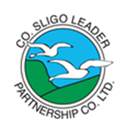
Sligo LEADER Partnership CLG

COVID19
COMMUNITY RESPONSE FUND (SICAP)
APPLICATION FORM
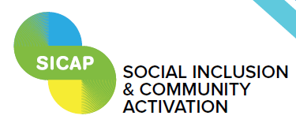
Return Completed Applications to eharan@sligoleader.com by 4th of September 2020

Please Indicate if you are a Community Group Social Economy Project
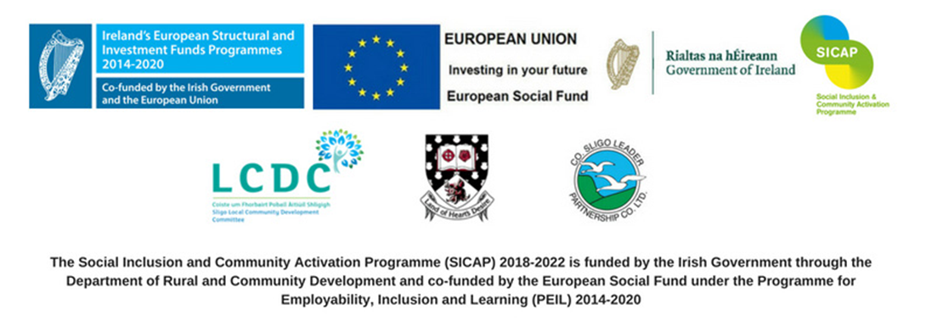

COVID19 – COMMUNITY RESPONSE FUND (SICAP)
Name of Local Community Group / Organisation
Address / Area Covered

Contact Name
Mobile Number

Please provide a brief description of your community re-opening needs in light of COVID19 restrictions, and how this will enable your group to continue your community development services:
Please provide details of the support that your group is seeking assistance with from the fund i.e. what support do you need?
Please provide details of the priority expense items that you seeking support with from the funds. Where possible keep these to 3 priority expense items, supported by a quotation. Include details of suppliers that you expect to source the goods/services from.
Expense Item |  | Expected Supplier | € Expected Cost  (need a quotation)
Total Expected Cost |  |  | €
IMPORTANT NOTE: running costs and staff costs are ineligible

Thank you for completing the application form.
Please return the completed form to eharan@sligoleader.com
A member of the SICAP team will be in contact with you as soon as possible.

