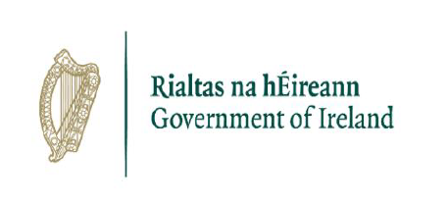

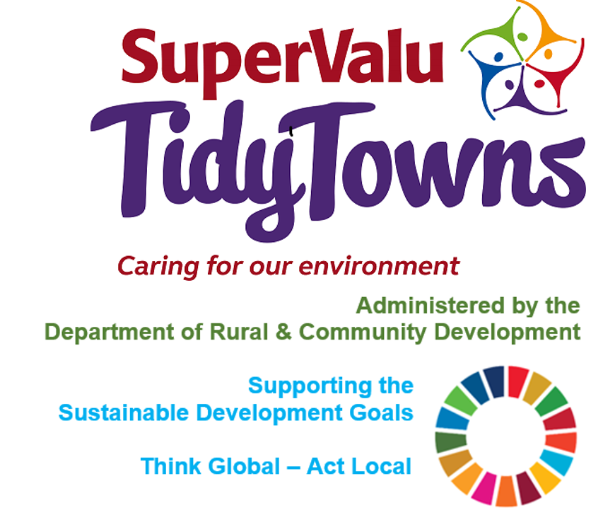

**Pobal**

[tidytowns@pobal.ie](mailto:tidytowns@pobal.ie)

**All Ireland Pollinator**

<https://pollinators.ie/new-publication-celebrates-first-five-years-of-the-all-ireland-pollinator-plan/>

<https://pollinators.ie/working-together-for-biodiversity/final-review/>

**Biodiversity**

[www.waterfordlibraries.ie/biodiversity-on-your-doorstep](http://www.waterfordlibraries.ie/biodiversity-on-your-doorstep)

<https://www.eventbrite.ie/e/giving-your-garden-back-to-nature-a-talk-by-mary-reynolds-tickets-140064224867>

<https://www.eventbrite.ie/e/bees-birds-trees-biodiversity-waterford-council-tickets-140106740031>

[www.nature.librariesireland.ie](https://www.nature.librariesireland.ie).

<https://www.eventbrite.ie/e/discover-the-new-wildlife-of-ireland-map-tickets-139955642093>

[www.facebook.com/eudirect](http://www.facebook.com/eudirect)

<https://www.eventbrite.ie/e/learn-how-to-spot-spring-flowers-and-become-a-citizen-scientist-tickets-139945491733>

**Pollinators awards**

<https://www.pollinators.ie/wordpress/wp-content/uploads/2019/03/Tips-on-entering-Tidy-Towns-Pollinator-Award.pdf>

<https://www.facebook.com/OfficialSuperValuTidyTowns>



[Description: Description: Description: https://encrypted-tbn2.gstatic.com/images?q=tbn:ANd9GcTn6e_yvEEKZGqngkOvFQKXiE5grEl9MBv8f3BIJGAnDVia4IA6BMWDw64](https://www.google.ie/url?q=https://about.twitter.com/press/brand-assets&sa=U&ei=gIVOU7azCeed7Qafq4DoCw&ved=0CC4Q9QEwAQ&sig2=_2Ys344bv7jS9rXT1Izm4w&usg=AFQjCNEMyI7-tFvyJYa1KkCdXm5XILcS9g)   <https://twitter.com/TidyTownsIre>



<https://www.tidytowns.ie>

**Tidytown email**

[tidytowns@drcd.gov.ie](mailto:tidytowns@drcd.gov.ie)