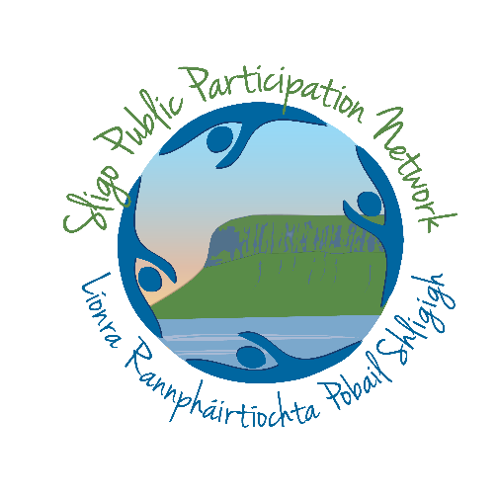

Sligo Public Participation Network (PPN)

Strategic Work Plan 2021

Preface – PPN Secretariat

The Secretariat of Sligo Public Participation Network (PPN) is delighted to present this Strategic Workplan for 2021. This plan sets out the priority areas for progress for the PPN as we work to represent and support a diverse and ever growing membership base.
This year the workplan is a little bit different, in that it will be an ever evolving document to reflect the conditions under which we find ourselves operating as a result of Covid-19 restrictions. It is based on the premise that the first half of the year will still see stricter social distancing measures in place and thus much of our work will be remote / online based. In the second half of the year we hope that such restrictions will have been largely removed and thus have chosen, at this time, to also allow for events such as the PPN Awards and the PPN Environment Seminar be included.
All the programmes and initiatives detailed are either aligned to national direction and our key aims of informing policy and ensuring community representation, or have been developed in direct response to the issues that our member groups raised as part of our 2020 needs analysis (Appendix 1) and health and wellbeing consultation process. Full Needs Analysis Report at; https://www.sligoppn.com/needs-analysis- results-and-response-plan/
If you want to read about our efforts in 2020, the Sligo PPN Annual Report can be found on the website; www/sligoppn.com

Who We Are

Sligo PPN was setup as part of Local Government Reform in late 2014 with the Secretariat elected in November the same year.

Sligo PPN is a network of community and voluntary groups based in the county. The purpose of the PPN is to empower and assist groups to participate in local decision making. The PPN is the main way through which the community and Sligo County Council share information.

It does not cost anything to register with the PPN and we encourage all eligible community and voluntary groups to join us.
Covid-19 has had a major impact on the work of the PPN and its member groups. Up until now, PPNs have been ideally placed at the centre of the community mobilisation effort to support the most vulnerable in our community. While many of the initial projects planned for 2020 had to be postponed, these were replaced by initiatives that we hope supported our members through this difficult time. It is envisaged that certainly the early stages of 2021 will echo this type of need for changing and reactionary responses, combined with the delivery of core objectives, where achievable.

Current Secretariat: Elected April 2018 and Nov 2019

Back Row L-R
David Tuffy: Rep for Ballymote-Tobercurry MD, Pat Benson (Social Inclusion), Paul Tolan: Rep for Sligo-Drumcliff MD, Lisa Moore: Rep for Borough District of Sligo MD, Michael Kirby (Environment)

Front Row L-R
Gerry O’Connor (Community & Voluntary) Ann Donnegan (Social Inclusion), Michael Bell (Environment) , Ann Marie Snee (Community & Voluntary- Now resigned)

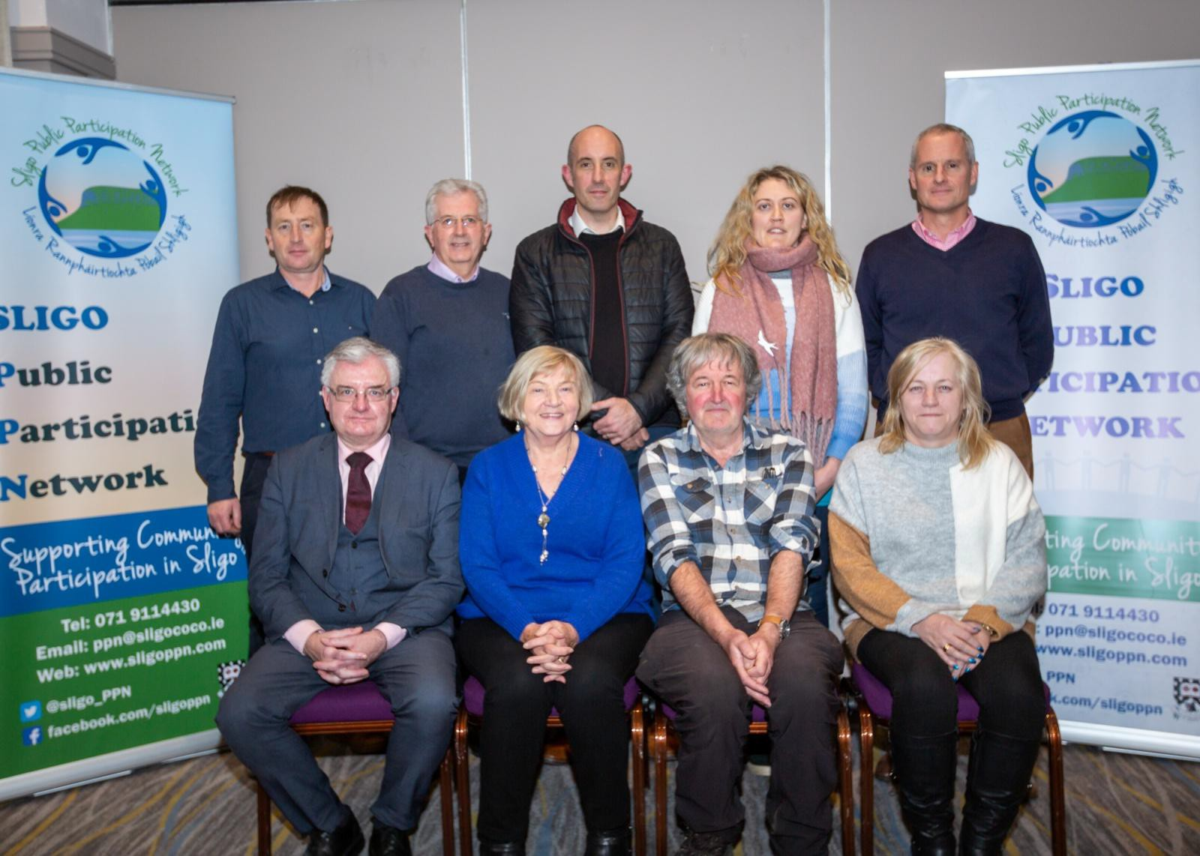

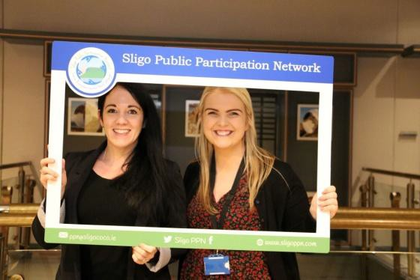
PPN Staff : Sarah Wetherald (PT) and Emer McGrath (FT)

Sustainable Development Goals (SDGs)

Sligo PPN support and are committed to the achievement of the Sustainable Development Goals. In our work we will endeavor, wherever possible, to operate with the SDGs in mind.
The Sustainable Development Goals (SDGs) or Global Goals are a collection of 17 interlinked global goals designed to be a "blueprint to achieve a better and more sustainable future for all". The SDGs were set in 2015 by the United Nations General Assembly and are intended to be achieved by the year 2030. They are included in a UN Resolution called the 2030 Agenda or what is colloquially known as Agenda 2030.
The 17 SDGs are: (1) No Poverty, (2) Zero Hunger, (3) Good Health and Well-being, (4) Quality Education,
- Gender Equality, (6) Clean Water and Sanitation, (7) Affordable and Clean Energy, (8) Decent Work and Economic Growth, (9) Industry, Innovation and Infrastructure, (10) Reducing Inequality, (11) Sustainable Cities and Communities, (12) Responsible Consumption and Production, (13) Climate Action, (14) Life Below Water, (15) Life On Land, (16) Peace, Justice, and Strong Institutions, (17) Partnerships for the Goals.

Though the goals are broad and interdependent, two years later the SDGs were made more "actionable" by a UN Resolution adopted by the General Assembly. The resolution identifies specific targets for each goal, along with indicators that are being used to measure progress toward each target. The year by which the target is meant to be achieved is usually between 2020 and 2030. For some of the targets, no end date is given.

To facilitate monitoring, a variety of tools exist to track and visualize progress towards the goals. All intend to make data more available and more easily understood. For example, the online publication SDG-Tracker, launched in June 2018, presents available data across all indicators. The SDGs pay attention to multiple cross-cutting issues, like gender equity, education, and culture cut across all of the SDGs. There were serious impacts and implications of the COVID-19 pandemic on all 17 SDGs in the year 2020.

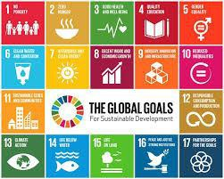You can find out more about the SDGs at https://sdgs.un.org/goals

PPN Membership Profile – Jan 2021

Membership Numbers: The PPN is made up of approximately 451 member organisations across 3 electoral pillars; Community & Voluntary, Environment and Social Inclusion
Electoral Areas: 38.58% of groups in Sligo-Strandhill Borough MD, 22.39% of groups in Ballymote-Tubbercurry MD, 36.36% of groups in Sligo- Drumcliff MD

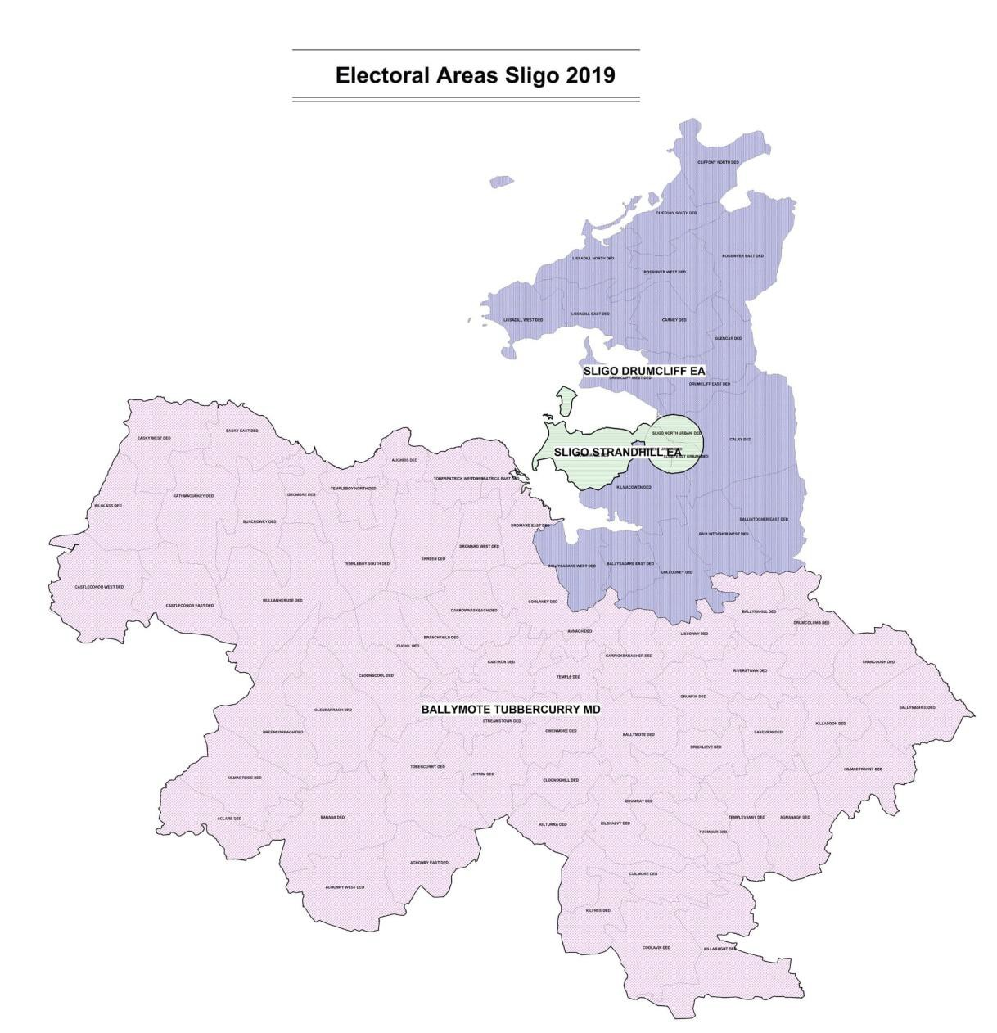

451 PPN
member Groups
The Borough district of Sligo
–Strandhill MD 164 member Groups

MEMBERS
Sligo-Drumcliff MD
101 Member Groups

Swords

19

Ballymote- Tobercurry MD 174 Member Groups
391
36
13
Community & Voluntary College
Social Inclusion College Environmental College

Workplan 2021 Summary

Strengthening Our Network |  | Alignment to Sligo LECP | Alignment to SDGs
Priority 1 | Grow PPN membership and raise awareness of the network | 4.3.1 | 11, 17
Priority 2 | Ensure the operational Sustainability of the PPN | 4.3.1 | 11
Priority 3 | Operate the network to the highest possible standard | 4.3.1 | 11
Priority 4 | Local Partnerships | 4.3.1 | 17
Priority 5 | Development Support for Member groups | 4.3.1 | 11, 10

Improving Our Representation Influencing Policy |  | Alignment to Sligo LECP | Alignment to SDGs
Priority 6 | Reviewing Representation and Remaining Relevant | 4.3.1, 3.1.5 | 11
Priority 7 | Supporting Representatives to have their Voice heard | 4.3.1,3.1.5, 3.5.1, 4.2.4, | 11
Priority 8 | Further develop relationships between the PPN and Public Representatives | 4.3.1 | 17
Priority 9 | Progress key policy positions | 4.5.1 | 3, 10, 11, 13

Improving our Communications |  | Alignment to Sligo LECP | Alignment to SDGs
Priority 10 | Development of PPN Website | 4.3.1 | 11
Priority 11 | Showcasing our Achievements | 4.3.1 | 11
Priority 12 | Continue to Implement a comprehensive Communications approach | 4.3.1 | 11

Secretarial Development and Administration |  | Alignment to Sligo LECP | Alignment to SDGs
Priority 13 | Ensuring Secretarial Oversight and Development | 3.1.5 | 11
Priority 14 | Administration | 4.3.1 | 11
Priority 15 | Fulfilling National Reporting Commitment | 4.3.1 | 11

National Networking |  | Alignment to Sligo LECP | Alignment to SDGs
Priority 16 | The goals of the PPN are progressed through national  networking | 4.3.1 | 11, 17

Covid 19 |  | Alignment to Sligo LECP | Alignment to SDGs
Actions | A series of actions will be developed in reaction to  emerging needs and in partnership with Community Call |  | 3, 17

Strengthening our Network

Overview
The PPN is nothing without the support of the local community. Sligo PPN will enhance its engagement with local people and groups and create a system of effective communications across members. Sligo PPN will continue to develop and grow its network, increasing the numbers of people involved, and guaranteeing high quality oversight and governance.

Priority 1 : Grow PPN membership and raise awareness of the network Actions
  - Support and engage with any national campaigns.
  - Work with relevant support agencies such as Sligo County Council, Sligo Sport and Recreation partnership, Sligo Leader Partnership Co and Sligo Volunteer Centre to encourage groups they work with to join the PPN
  - Produce an informative and relevant ‘Reps Update’ piece based on information received each quarter for distribution to PPN network and website
  - Continue a Strong social media presence across Twitter and Facebook
  - Look for opportunities to promote the PPN in local community publications
  - Work with key traditional media outlets to ensure the broader community are made aware of the work of the PPN

Priority 2 : Ensure the operational Sustainability of the PPN Action
  - Continued Employment of a dedicated part time PPN development worker and full time support worker. Where possible the Secretariat will try and ensure continuity of staff to allow for PPN progression and growth of the network.

Priority 3 : Operate the network to the highest possible standard Actions
  - Review and implement the revised PPN User Guide. Disseminate the User Guide to relevant partner organisations and stakeholders
  - Consultation on and feed into the 2021 Structural Review. This will be direct input from RW, consultation at county level with PPN members, representatives, Local Authority staff and Elected Members
  - Participation in national training programme 2021 and promote same to members, representatives and Local Authority Staff. Restrictions will determine if this is in blended learning format or all online. PPN will organise local involvement.

  - The Sligo PPN RW represents the Resource Workers Network on the National PPN Advisory Group and will have input into the structure and future planning of the national network. The Sligo PPN Resource worker attends NAG meetings every 2 months as well as engaging in ongoing national work.
  - Sligo PPN RW is also a member of the team overseeing the National Communications Strategy
  - The PPN Resource worker will continue to attend and inform the National PPN Workers Network and the regional PPN meetings to ensure continued learning and sharing of emerging good practice. These meetings will take place online until restrictions are lifted.
  - The PPN Support Worker is part of the national Support Worker Network
  - Sligo PPN is represented on the National Secretariat Network by Gerald O’Connor

Priority 4 : Local Partnerships Actions
  - To continue the development of our partnership with ITSligo to ensure that the PPN is able to base activity on the highest quality and most up to date research and information. This partnership helps build strong connections between ITSligo and the local community and helps to ensure that some of the brightest academic support is available to Sligo PPN in progressing the concept of public participation.
  - Work with ITSligo to create an online platform to allow community members to raise issues of collective concern and to identify best pathways for solution. This was due to be launched in 2020 but has been postponed until 2021.
  - To explore opportunities to work closely with the Age Friendly Sligo initiative to ensure that the voice of older people is represented
  - To work alongside Healthy Sligo in the promotion of community wellbeing as a county priority.

Priority 5 : Development Support for Member groups Actions
  - Work with key training providers in the county (Sligo Leader Partnership, Sligo Volunteer Centre, MSLETB) to deliver a coordinated response programme to our 2020 Needs Analysis. Initial actions include;
Social Media Training
Development of a guide for Residents Associations
  - Continue to promote and lobby on behalf of member groups around key issues affecting the sector.
  - Continue to work with the Alliance for Insurance Reform on the escalating community group insurance issue.
  - Feed into key county submissions as they arise and support member groups to do same

Improving our Representation and influencing Policy

Overview
The core ethos behind the PPN is to create a structure that supports the community voice to be heard. As PPN Secretariat it is our role to both support community organisations and representatives to inform and influence through strengthening their capacity as well as working with committees to ensure that their operating practise is inclusive and allows for real opportunity for community members to have their opinions heard.

Action 6 : Reviewing Representation and Remaining Relevant Actions
The PPN is the most important and effective way for local people to influence local planning and decision making. It is critical that this representation is reflective of the increasingly diverse make up of the Sligo community.
  - Host information seminars to ensure our members and the wider community are aware of key national initiatives that have implications in the county.
  - To review representation and explore opportunities for more diversity in the PPN membership

Priority 7 : Supporting Representatives to have their Voice heard Actions
  - To host and promote the national training programme aimed at PPN Staff, PPN Representatives and members, Local Authority Staff and Elected Members
  - To work with other PPNs to assess the current experience of PPN representatives on SPC committees and to work collectively to make recommendation for enhanced experience
  - To ensure that Sligo PPN participates fully in the national structural review which seeks to work with all stakeholders to enhance the experience of public participation at national level and to improve the opportunity for community to inform and influence public policy and programme development
  - Offer training to reps on the workings of local government and influencing policy
  - Promote all public participation and policy influencing opportunities that the PPN become aware of
  - To develop a connection between elected PPN representatives on the SPCs and committee chairs to facilitate input from PPN reps and to open up opportunities for exploring joint priorities
  - To host online meetings with PPN representatives prior to their attendance at SPC and other key committees to support their preparation.
  - To engage with national consultation processes, wherever the opportunity arises
  - Maintain ongoing contact with SPC and other committee administrators to ensure that the PPN is made aware of upcoming meetings and events and meetings so that they can support reps to prepare
  - To bring all the PPN community reps together in the final quarter of 2021 to share experiences, make recommendations for improvement and to highlight priorities for inclusion in subsequent PPN work plans.
  - To undertake necessary election processes. To date scheduled for 2021 include; Sligo Heritage Forum
PPN Secretariat
Sligo Place Names Committee Sligo LCDC
SPC

Priority 8 : Further develop relationships between the PPN and Public Representatives and the Local Authority
In order for the PPN to effectively progress issues, beneficial and supportive relationships need to be continually developed between the PPN and Public Representatives. To further support this, and to raise awareness with public representatives as to the benefits of engaging with PPNs, the following will be done:
  - Ensure Public Representatives are kept up to date on PPN activity through circulating newsletters and activity reports.
  - Ongoing reporting on PPN activity to Sligo County Council Management and Sligo LCDC. Promotion of document outlining relationship between PPNs and LAs
  - Encourage LA staff and elected members to attend national PPN training programme
  - Encourage LA staff and elected members to actively participate in the PPN Structural Review and to work with the PPN to implement recommendations

Priority 9 : Progress Key policy positions

Actions
  - To undertake the next phase of the Sligo PPN Wellbeing Vision initiative which will see the feedback from our countywide public consultation developed into a wellbeing vision document for the county. The data will also be used to develop an index of priorities which can influence local planning and policy development as well as a mandate for PPN representatives on key committees to ensure that they are representing the priorities of the community they represent.
  - To enhance the environmental priorities of the PPN through a series of initiatives such as our environmental support for community groups and environment seminar.
  - To work with DRCD and DECC to ensure that PPNs are at the forefront of the consultation process for the New Climate Action Plan 2021
  - To continue to advocate on behalf of PPN reps for equality and inclusion with regard to informing policy development and strategic planning.

Improving our Communications

Overview
Good communications across the membership and between the PPN and other stakeholders is key to ensuring the success of the PPN work. Phase 1 of the PPN process was to focus on the development of strong operational procedures and creating a robust governance structure. It is now time to spread the word about what we have achieved and to enhance the way we communicate with the broader community.

Priority 10 : Enhancement of PPN Website Actions
  - Organise and update the PPN website to reflect key national and local developments and to facilitate sharing of information, particularly in relation to Covid-19
  - Work with web designers and interested members to review the current website and to enhance it in regard to accessibility and relevance to the community sector

Priority 11 : Showcase our achievements Actions
  - To showcase and promote the work of our member organisations through social media platforms and for inclusion in the PPN newsletters
  - To work with social media campaigners to support our member groups to raise their profile through the development of promotional videos which can be used to not only attract new members but to also support funding applications.
  - To host the inaugural PPN Community Awards Programme using an online promotional campaign which also supports selected groups to create their own publicity tools to engage new members and raise their profiles.

Priority 12 : Continue to develop a comprehensive communications approach Actions
  - Regularly continue to promote the PPN through weekly updates on Facebook, Twitter and Website and expand our audience on various social media platforms
  - Continue to liaise with traditional media outlets with press Releases and photos to the media following Plenary Meetings, Linkage Group Meetings, PPN Events and policy achievements/positions
  - Continue to develop and Distribute the quarterly newsletter
  - Use Social media to alert member groups to activities, funding opportunities and events rather than using continuous email.
  - Work with Department of Community and Rural Development and the national workers network to build a national profile/greater awareness for the PPN. As members of the national Communications Working Group, Sligo PPN will be directly involved the planning and roll out of the national communications initiative aimed at raising the national profile of PPNs.

Secretarial Development and Oversight

All of the PPN Strategic Actions are underpinned by a strong organisational structure and administrative support system. Here we detail some of the core work that goes on behind the scenes.

Overview
The Secretariat directs and drives the work of the PPN. The Secretariat acts with complete autonomy while maintaining clear oversight of all the work carried on under the auspice of the Sligo PPN
It is critical that the work of the PPN is organised, transparent and that good records are kept. All events and meetings should be managed effectively and members notified well in advance.
There is a strong mandate for reporting to the Department of Rural and Community Development on key elements of the PPN structure which calls for ongoing documentation of processes which will feed into an annual report for the Department

Priority 13 : Ensuring Secretarial Oversight
The Secretariat directs and drives the work of the PPN. The Secretariat acts with complete autonomy while maintaining clear oversight of all the work carried on under the auspice of the Sligo PPN
  - Secretariat Meetings held a minimum of 6 times per year, online where restrictions exist.
  - Creation of ‘executive committees’ on core themes such as governance and communication strategy
  - Check governance arrangements against the governance code
  - Invitation to selected PPN reps to attend Secretariat Meetings
  - Include strategic goals as agenda items at PPN meetings
  - Enable policy positions to be developed and provide supports for wider membership to influence policy

Priority 14 : Administration
It is critical that the work of the PPN is organised, transparent and that good records are kept. All events and meetings should be managed effectively and members notified well in advance.

  - Minutes and recording

  - Meeting agendas
  - Email and mail correspondence
  - Updating social media sites
  - Distributing and updating e-bulletin list
  - Organising Elections if necessary
  - Seeking quotes/financial oversight
  - Booking venues
  - Updating contact details of members
  - Updates to the LCDC

Priority 15 : Fulfilling National Reporting Commitment
  - Answer to all circulars
  - Reporting targets for correspondence, social media profiles, communications
  - Providing national updates at resource worker meetings
  - Completing Annual Report for submission to DRCD
  - Adoption, training and development of Salesforce

National Networking

Priority 16 : The goals of the PPN are progressed through national networking
  - Attendance at PPN Resource Worker meetings
  - Attendance at National Advisory Group
  - Attendance at national communications group
  - Attendance at PPN national conference
  - Attendance at regional meetings (to include reps)
  - Attendance at National Secretariat meetings

PPN Actions Under Covid-19

Community Response
  - To offer ongoing support to our community emergency response groups who are available to offer local supports to the most vulnerable in the community.
  - To continue to update our website and social media to reflect official information and guidelines .
  - To work with local media to highlight and promote the huge community effort under Covid-19
  - To participate as a member of the Sligo Community Response Forum, charged with developing a coordinated response under Covid-19

Community Group Support
  - To ensure that community groups are aware of all upcoming funding opportunities and to offer support in completing applications
  - To build on the 2020 needs analysis to deliver information/training that will support groups to survive across Covid-19 and to put in place plans for re-opening

Operational Changes
  - To instruct and adapt Secretariat members and PPN reps engagement sessions to an online format
  - To continue meeting cycles as normal but in an online format

Community Group Promotion
  - To continue to highlight the work of the community sector with a specific focus on their work in supporting the most vulnerable
  - To work with One Step Closer to deliver a series of online promotional opportunities for groups to raise their profile, engage members and support new funding opportunities

Wellbeing Vision
  - To use the experience of life under Covid-19 to strengthen the database for our Wellbeing vision. To identify how priorities change under a major disaster and to find out the impact on an individuals sense of health and wellbeing when our normal way of life is challenged. Special effort to be put into consulting with some of those groups most affected by the pandemic including children.

Project Delivery Summary

Title | Brief | Basis | Timeline | Status | Alignment  to SDGs
Social Media Academy | In response to our 2020 needs analysis we will be rolling out a 2 phase social media programme.  Phase 1 will be the development and delivery of online training and videos and hard guides. Phase 2 will be Mentor clinics and one-to-one advice. | 2020 Needs Analysis 60% of all respondents identified as priority | Videos to be released in January. Promotion of mentor clinics to follow in February | Online social media academy launched Jan 21 | 10
 |  |  | Clinics to start March
New Climate Action Plan | PPNs are at the forefront of the consultation process for the New Climate Action Plan as a corroboration between DECC and DRCD. PPN staff and members will undergo training to act as moderators and will host a series of local consultations | This is a project initiated by DRCD and DECC | Initial planning with DECC Jan 21  Moderator training Feb 21 | SSligo confirmed as pilot consultation site 10th Feb | 3,6,11,12,13,14,15,17
Health and | Completion of consultation | Mandated national | Consultation and | Review of | 3, 11
Wellbeing Vision | Compilation of data | action | compilation to be | consultation
 | Production of; |  | complete by late | data has begun
 | Wellbeing Vision for Sligo |  | February
 | Mandate for PPN Reps |  | Document
 | Index of priorities for future policy and planning |  | development
 |  |  | March/April
Residents | In response to a number of issues that have come | Identified as a gap in | Development of | Review of | 11
Association | to us with regard to the operation of Residents | the 2020 needs analysis | Guide Feb-Mar | existing
Guide | Association, the PPN will look to put a guide |  | Publication March- | documentation
 | together to support these groups to either |  | April | has begun
 | establish or improve operation
Tidy Towns Support | To work with TT groups to identify training and information that will support them to prepare for the 2021 competition and specifically to enhance  their alignment to key local environmental priorities as raised in the H&W vision | Approach made to PPN following announcement that  2021 programme to proceed | Call out to groups in January /February |  | 11, 3, 17, 13, 4

Environment Seminar | Environment college will work with SEAI, ITSligo to host an event which explores renewable energy for homes and communities, offering easy to understand advice on available options and tailored support advising suitability | Proposal from Environment College | Postponed from 2020.  Reschedule dependent on Covid-19  restrictions |  | 13, 17, 4
Environmental support for groups | To work with SCC Env Section and SEN to explore development of guide for community sector to support them to become more environmentally friendly in their everyday practise. | 2020 Needs Analysis  63% of respondents identified as a priority | Postponed from 2020  To begin in line with easing of Covid restrictions |  | 17, 13, 11, 4
EC Promotional Document | Development of a promotional document for the EC detailing each member group and what they do – all set in the scene of the key environmental priorities for Sligo | Climate direction from DECC and DRCD | Draft beginning in February 21 |  | 17,13, 11, 4
PPN Awards | The PPN aim to host an awards ceremony which will celebrate the contribution of the community sector and offer an opportunity for sharing of  ideas and networking. The event will be in partnership with ITSligo | An event that is popular across most PPNs and agreed by Secretariat | Postponed from 2020  Sept / Oct 2021 |  | 11, 17
PPN Member group promotion | In the build up to the PPN Awards Ceremony, groups will be given the opportunity to apply to get the opportunity to have a promotional video developed which will help them grow membership, raise their profile and support funding opportunities. | In response to 2020 needs analysis and identification that groups need additional support to get started following Covid-19 | Dependent on social distancing regulations
Kid’s Own Youth Consultation | The PPN are working with Kid’s Own to capture the experiences of children under Covid-19 and to identify their wellbeing priorities for the future. As well as the publication of an independent book the findings will also inform the H&W vision and mandate documents. | Close alignment to H&W vision  In line with a call to ensure more diversity in the voices reflected through the PPN | Consultations to resume as soon as schools reopen in 2021 – Covid restriction dependent  Data to feed into  wellbeing vision | Consultations have started | 11
Website Review and enhancement | To undertake a review of the current website from an accessibility and relevance perspective. This will involve getting together a group of PPN  representatives from the social inclusion college to | As the world moves online even further – it is essential the PPN  main communication | Review of content in terms of relevance across  January | Call out for costing | 11,

 | work with staff and web designers to improve the site for all. | hub is accessible and relevant to all | Group approach to  begin February/March
Updated Funding Guide | To ensure that all our funding information is up to date and most relevant to the new climate. We will attempt to ensure that our funding information is relevant to emerging funding  rounds across 2021 | 2020 Needs Analysis  74% of respondents identified as a priority. | Review of current documents in January |  | 11
National PPN training programme | The North West is scheduled to host the national PPN training programme in 2021. This is aimed at PPN representatives, staff, Local Authorities and  elected members. | National Initiative | Notification of dates to come direct from DRCD |  | 4, 17

PPN Election Information 2021
Committee | Brief Notes | Basis | Timeline
Secretariat Elections | Elections are due for a number of current Secretariat positions | Part of core PPN brief | Nomination and voting forms developed across January – for review by SCC in February Nominations to  open late March |  | 11
Election for LCDC | There is one seat for PPN representatives on the LCDC in the social inclusion college. | Part of core PPN brief | Nomination to be timed in line with Secretariat elections |  | 11
Election for Heritage Forum | There are 3 PPN seats available on the Heritage forum | Part of core PPN brief | Mock forms with Heritage Officer for  review since |  | 11, 13

October 2020. Date for opening of nominations dependent on
approval.
Election for Place  Names Committee | There is 1 seat available for PPN reps | Part of core PPN brief | In line with heritage forum |  | 11
Age Friendly Alliance | There is to be 1 seat available to reps from the social inclusion college | Part of core PPN brief | Awaiting guidance from SCC with regard to opening  nominations |  | 11

Calendar of Activity TO BE UPDATED AND FINALISED ONCE WORKPLAN AGREED
1st Quarter Jan to Mar | 2nd Quarter April to June | 3rd Quarter July to Sept |  | 4th Quarter Oct to Dec
Recruitment of Reps, Heritage Forum & Place Names | National Training Programme | PPN Awards Event |  | AGM
Kids Own Consultation | Kids Own Publication |  |  | Annual Report
NAG meeting | NAG meeting | NAG meeting |  | NAG meeting
Release of online Social Media content | Environmental Seminar
Environmental Support programme | Holding elections for Secretariat
Community Call involvement | Social Media Mentor Clinics
Begin Website Review and enhancement
Daily updates social media/extending Facebook audience | Weekly updates social media | Weekly updates social media |  | Weekly updates social media
Health and Wellbeing finalise consultation and draft content | Wellbeing Vision production
Residents Association Document | St Patricks Day Newsletter | Reps Collective event
Q1 Newsletter | Q2 newsletter | Q3 Newsletter |  | Q4 Newsletter
NWR Meeting | One Step Closer Initiative | NWR meeting
Secretariat Meeting x 2 | Secretariat Meeting x2 | Secretariat Meeting x 2 |  | Secretariat Meeting

PPN Admin | PPN Admin | PPN Admin | PPN Admin
National RW Meeting | National RW Meeting | National RW Meeting | National RW Meeting
Residents Association Guide |  | National Conference
Report to LCDC | Report to LCDC | Report to LCDC | Report to LCDC

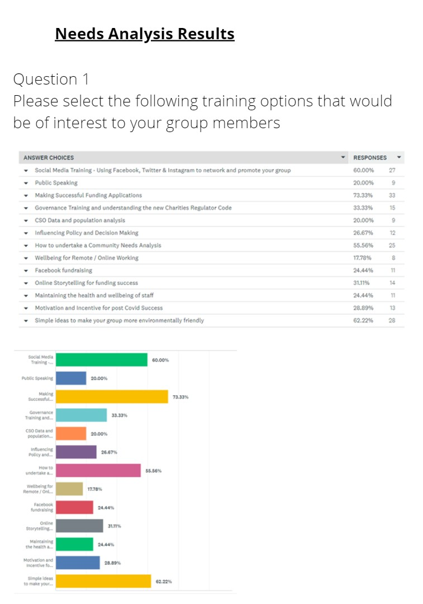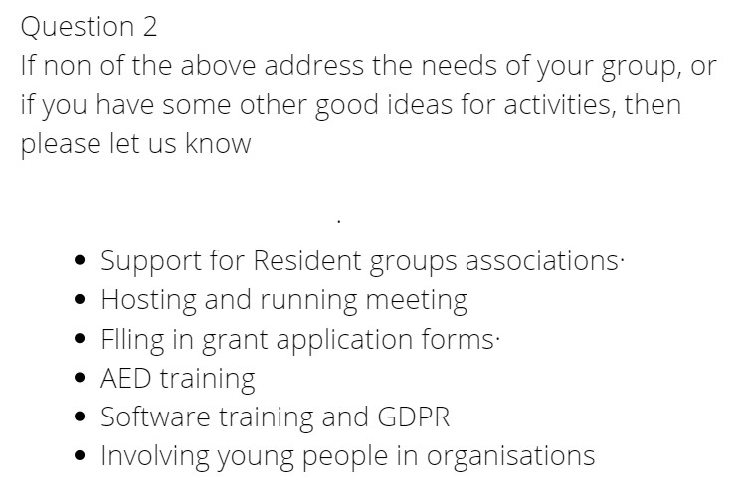Appendix 1

