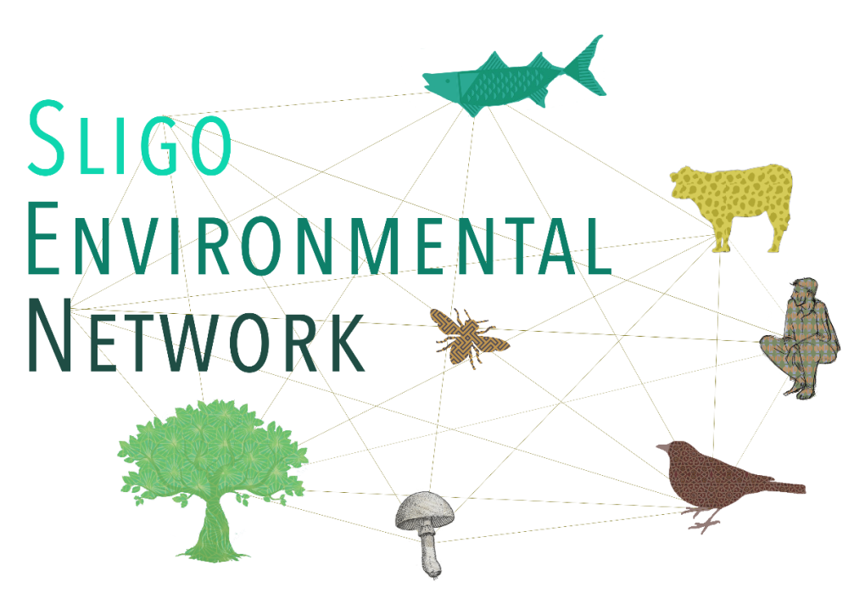

|  |  |  |  |  |  |  |  |  |  |  |  |  |  |  |  |  |  |  |  |  |  |  |  |  |  |  |  |  |  |  |  |  |  |  |  |  |  |  |  |  |  |  |  |  |  |  |  |  |  |  |  |  |  |  |  |  |  |  |  |  |  |  |  |  |  |  |  |  |  |  |  |  |  |  |  |  |  |  |  |  |  |  |  |  |  |  |  |
| --- | --- | --- | --- | --- | --- | --- | --- | --- | --- | --- | --- | --- | --- | --- | --- | --- | --- | --- | --- | --- | --- | --- | --- | --- | --- | --- | --- | --- | --- | --- | --- | --- | --- | --- | --- | --- | --- | --- | --- | --- | --- | --- | --- | --- | --- | --- | --- | --- | --- | --- | --- | --- | --- | --- | --- | --- | --- | --- | --- | --- | --- | --- | --- | --- | --- | --- | --- | --- | --- | --- | --- | --- | --- | --- | --- | --- | --- | --- | --- | --- | --- | --- | --- | --- | --- | --- | --- |
| |  |  |  |  | | --- | --- | --- | --- | | |  |  |  | | --- | --- | --- | | |  |  | | --- | --- | | |  | | --- | | [View this email in your browser](https://scanner.topsec.com/?u=https%3A%2F%2Fmailchi.mp%2F09f20e07dbc3%2Fsligo-environmental-network-newsletter-7357701%3Fe%3Da0986157d2&d=1446&t=845f3892f4fd47704a029eb374e4c8e9913893f5) | | | | | |  |  |  | | --- | --- | --- | | |  |  | | --- | --- | | |  | | --- | |  | | | | | |  |  |  | | --- | --- | --- | | |  |  | | --- | --- | | |  | | --- | | ****Newsletter January 2021**** Welcome to our first newsletter of 2021. It has been a January like no other that we have known, as the Covid Pandemic continues and we are in a continuous cycle of restricted living. It has been challenging for many, and we hope that you are all keeping safe and maintining a positive outlook.   This time of year is typically spent Spring Cleaning. It can be marked by discovering tins of food that have a best before date of 2018, or finding long lost items that had been put away safely, or finally sorting out the famous "middle drawer" where all the bits and bobs are thrown during the year. Another essentail element of the Spring Clean is the wardrobe clear out. As you embark on this task we ask you to think about how you could reinvent your old clothes and have Sustainable Fashion as a theme of this newsletter.  Sligo Climate Generations provide a showcase of material around Fast Fashion. Our chairperson Tracy Kilgallon has been running workshops on Sustainable Fashion and provides information where you can learn more about this topic.   In each newsletter we aim to highlight the work of SEN members and share experiences of being an SEN member. The work of Sligo Cycling Campaign features in this newsletter. Deni O'Toole who facilitated the networks "Social media messaging Zoom gathering" on 27th January 2021 shares her experience of SEN.  We hope that you enjoy reading the newsletter and welcome any feedback and contibutions to future newsletters. Please email [sligosennewsletter@gmail.com](mailto:sligosennewsletter@gmail.com). | | | | | |  |  |  |  |  |  |  |  |  |  |  |  |  |  |  |  |  |  |  |  |  |  |  |  |  |  |  |  |  |  |  |  |  |  |  |  |  |  |  |  |  |  |  |  |  |  |  |  |  |  |  |  |  |  |  |  |  |  |  |  |  |  |  |  |  |  |  |  |  |  |  |  |  |  | | --- | --- | --- | --- | --- | --- | --- | --- | --- | --- | --- | --- | --- | --- | --- | --- | --- | --- | --- | --- | --- | --- | --- | --- | --- | --- | --- | --- | --- | --- | --- | --- | --- | --- | --- | --- | --- | --- | --- | --- | --- | --- | --- | --- | --- | --- | --- | --- | --- | --- | --- | --- | --- | --- | --- | --- | --- | --- | --- | --- | --- | --- | --- | --- | --- | --- | --- | --- | --- | --- | --- | --- | --- | --- | | |  |  | | --- | --- | | |  | | --- | |  | |  |  |  |  | | --- | --- | --- | | |  |  | | --- | --- | | |  | | --- | | **Fast Fashion - Sligo Climate Generations** | | |  |  |  | | --- | --- | | |  | | --- | | Over the last few months some teenagers and older people in Sligo have taken part in Sligo Climate Generations. Face-to-face meetings were not possible, therefore participants connected via Zoom and through letters. The younger people watched the short documentary [Textile Mountain](https://scanner.topsec.com/?u=https%3A%2F%2Fitsligo.us10.list-manage.com%2Ftrack%2Fclick%3Fu%3Dd4fc7772a67b1bff3c78b0139%26id%3Dc90f5d0044%26e%3Da0986157d2&d=1446&t=4d70d2712092425275efae2171297042cf089ee7) and then connected with the filmmaker Fellipe Lopes for a Q&A. Questions around consumerism, waste and pollution were then discussed via letters with the older people and many of the participants - between 14 and 89 - shared creative contributions around ‘Fast Fashion’.    The project is funded by the **Older Persons’ Fund of the Community Foundation Ireland**. | |  |  |  | | --- | --- | | |  | | --- | | **Slow Fashion - by Mairead Conway** | |  |  |  | | --- | --- | | |  | | --- | | https://mcusercontent.com/d4fc7772a67b1bff3c78b0139/images/217399ce-1f8f-456d-93c0-1d859b7c32ff.jpeg | |  |  |  | | --- | --- | | |  | | --- | | **Fast Fashion - by Mairead Conway** | |  |  |  | | --- | --- | | |  | | --- | | https://mcusercontent.com/d4fc7772a67b1bff3c78b0139/images/89b2b15d-5129-4914-b6e8-eca2b6ab4b7c.jpeg | |  |  |  | | --- | --- | | |  | | --- | | **Zine on Fashion Pollution - by Caoimhe Davidson** | |  |  |  | | --- | --- | | |  | | --- | | https://mcusercontent.com/d4fc7772a67b1bff3c78b0139/images/55e60b32-48db-4e0f-9db8-b8272b5e313d.jpeg | |  |  |  | | --- | --- | | |  | | --- | | [**POETRY LINK - TOO MUCH NEVER ENOUGH by Kathleen Glennon**](https://scanner.topsec.com/?u=https%3A%2F%2Fitsligo.us10.list-manage.com%2Ftrack%2Fclick%3Fu%3Dd4fc7772a67b1bff3c78b0139%26id%3De590be6e52%26e%3Da0986157d2&d=1446&t=bcbcbb0d6fee70264bee8f115e608dda268b2c96) | |  |  |  | | --- | --- | | |  | | --- | |  | |  |  |  |  | | --- | --- | --- | | |  |  | | --- | --- | | |  | | --- | | **Information on Sustainable Fashion** | | |  |  |  |  | | --- | --- | --- | | |  | | --- | | The following links are provided to assist in discovering more about Sustainable Fashion.  Documentaries and Videos              [Textile Mountain](https://scanner.topsec.com/?u=https%3A%2F%2Fitsligo.us10.list-manage.com%2Ftrack%2Fclick%3Fu%3Dd4fc7772a67b1bff3c78b0139%26id%3D9612ab852e%26e%3Da0986157d2&d=1446&t=a039bc0c367eae7ad926520936247efb7748065e) [The True Cost](https://scanner.topsec.com/?u=https%3A%2F%2Fitsligo.us10.list-manage.com%2Ftrack%2Fclick%3Fu%3Dd4fc7772a67b1bff3c78b0139%26id%3D284146c237%26e%3Da0986157d2&d=1446&t=60d9e04dd442f990e2c24e31e0a53b0f4cc795a9) [River Blue](https://scanner.topsec.com/?u=https%3A%2F%2Fitsligo.us10.list-manage.com%2Ftrack%2Fclick%3Fu%3Dd4fc7772a67b1bff3c78b0139%26id%3D594c3930ee%26e%3Da0986157d2&d=1446&t=d1228bb8d2f51580f00325dadba54fe7e43f5f80)  [Zero Waste Daniel](https://scanner.topsec.com/?u=https%3A%2F%2Fitsligo.us10.list-manage.com%2Ftrack%2Fclick%3Fu%3Dd4fc7772a67b1bff3c78b0139%26id%3Df88dd8dc74%26e%3Da0986157d2&d=1446&t=ad0cde44c0d583a768444005690bf2dac4220fe5) [Disappearance of the Aral Sea](https://scanner.topsec.com/?u=https%3A%2F%2Fitsligo.us10.list-manage.com%2Ftrack%2Fclick%3Fu%3Dd4fc7772a67b1bff3c78b0139%26id%3D48ffd6c98e%26e%3Da0986157d2&d=1446&t=2adf0da71ece85a4a8e32220f245b2befb1ef383) |  |  | | --- | | Facebook Groups           What She Wore Zero Waste Freecycle pages Marketplace   Instagram                         The Useless Project (formerly Sustainable Fashion Dublin)  Thrifty | |  |  |  | | --- | --- | | |  | | --- | |  | |  |  |  |  | | --- | --- | --- | | |  |  | | --- | --- | | |  | | --- | | **Spotlight on SEN Members** | | |  |  |  | | --- | --- | | |  | | --- | | In each newsletter we wish to highlight the work of SEN members. If you wish to feature in this section please email details to [sligosennewsletter@gmail.com](mailto:sligosennewsletter@gmail.com). In this newsletter we highlight the work of ***Sligo Cycling Campaign*** and the bring your attention to the ***Love 30 Campaign***. | |  |  |  | | --- | --- | | |  | | --- | | **Sligo Cycling Campaign** wants to see Sligo become a cycle friendly town and county, safe and enjoyable for all ages to cycle in. We aim to raise public awareness of the benefits of cycling and promote and advocate for the improvement of cycling infrastructure in Sligo. We want people of all ages and abilities to be able to choose cycling as a realistic, safe, efficient and enjoyable way of getting around.  If you would like to get involved with Sligo Cycling Campaign you can email us @sligocycles@gmail.com or message us via our Facebook [https://www.facebook.com/SligoCyclingCampaign](https://scanner.topsec.com/?u=https%3A%2F%2Fitsligo.us10.list-manage.com%2Ftrack%2Fclick%3Fu%3Dd4fc7772a67b1bff3c78b0139%26id%3D7d7d5fb153%26e%3Da0986157d2&d=1446&t=8c73dfc0df9c1dde862d6d47002238b9675587fc)  or Twitter @SligoCycling  pages. | |  |  |  | | --- | --- | | |  | | --- | | [**Read more about Sligo Cycling Campaign**](https://scanner.topsec.com/?u=https%3A%2F%2Fitsligo.us10.list-manage.com%2Ftrack%2Fclick%3Fu%3Dd4fc7772a67b1bff3c78b0139%26id%3D8a7749296f%26e%3Da0986157d2&d=1446&t=aac4a6a85ef3140c965dfcc2bcd658a7371e32fd) | |  |  |  | | --- | --- | | |  | | --- | | https://mcusercontent.com/d4fc7772a67b1bff3c78b0139/images/79cd868d-e68d-456a-8351-720a079d8fb3.png | |  |  |  | | --- | --- | | |  | | --- | | [**Read more about Love 30 Campaign**](https://scanner.topsec.com/?u=https%3A%2F%2Fitsligo.us10.list-manage.com%2Ftrack%2Fclick%3Fu%3Dd4fc7772a67b1bff3c78b0139%26id%3D74eb405bee%26e%3Da0986157d2&d=1446&t=04f6f236b2c34a147a304b39701e3882bc130e86) | |  |  |  | | --- | --- | | |  | | --- | |  | |  |  |  |  | | --- | --- | --- | | |  |  | | --- | --- | | |  | | --- | | **Members Experience of the SEN** | | |  |  |  | | --- | --- | | |  | | --- | | I became aware of Sligo Environmental Network through reading about their inspiring Climate Wisdom project and seeing the art from their wonderful Climate Generations intergenerational participatory project for teenagers and older people on social media.   There was a march for Climate Change in Sligo on Sept 19th 2019. It was held on the same day as SENs  ‘Sligo Climate Wisdom’ (which was performed in Sligo Courthouse for Culture Night 2019). There was a successful collaboration between SEN and Fridays for Future in which the placards from the march were used at the Climate Wisdoms event that evening. Sligo students from Fridays For Future Sligo committee had organised the Climate Change march in solidarity with worldwide marches which was supported by large crowds here locally.  More than 500 second level students in Sligo marched in protest over lack of action on climate change and dozens of students from County Donegal protested outside Donegal County Council offices in Lifford.   The energy and positivity around Sligo Environmental Networks events, collaboration between different age groups, their positivity towards activism and activists, their strong focus on all environmental issues and welcoming atmosphere to all, were all instrumental reasons in my  joining the Network.  I attended a Network gathering in July 2020 and found the Network to be every bit and more inspiring and welcoming as I had thought looking in from a distance. It was also a really welcome way to connect with other like minded people in the year which Covid had impacted our lives so strongly .  As an activist I became interested and active in campaigning for social justice through the water charges, Yes Equality and Repeal movements. Through joining the Network I have met new people, learned new things, shared my skills,  practiced better self care and got out of my comfort zone both as an activist and a human !  I joined the committee at the end of last year SEN and am currently focusing on helping with social media management, developing and soon to deliver skill sharing workshop(s) to help individuals or groups use social media more effectively in their work with their group or cause. I would wholeheartedly recommend anyone to join the SEN Network. The time commitment can be as little or as much as you can give and there are numerous directions you can take here.  Le meas,  Deni. O'Toole | |  |  |  | | --- | --- | | |  | | --- | |  | |  |  |  |  | | --- | --- | --- | | |  | | --- | | **Upcoming Events**  Do you wish to share upcoming events and stories with Sligo Environmental Network members?  Please email contributions for consideration to the SEN newsletter to [sligosennewsletter@gmail.com](mailto:sligosennewsletter@gmail.com) |  |  | | --- | | **Have your Say**  Have you subscribed to the mailing list to be updated on information on public consultations held by government departments and local authorities. You can subscribe at the following website [https://www.gov.ie/en/consultations/](https://scanner.topsec.com/?u=https%3A%2F%2Fitsligo.us10.list-manage.com%2Ftrack%2Fclick%3Fu%3Dd4fc7772a67b1bff3c78b0139%26id%3Dee8a703246%26e%3Da0986157d2&d=1446&t=dbbd522e6ab4a032dd7f8d32be6edf9f8efbebfa)   The [Stop Ecocide Foundation](https://scanner.topsec.com/?u=https%3A%2F%2Fitsligo.us10.list-manage.com%2Ftrack%2Fclick%3Fu%3Dd4fc7772a67b1bff3c78b0139%26id%3D806b8ba7c5%26e%3Da0986157d2&d=1446&t=8428f969bc3797a51f8ccabdff06529e03b642bd) announced the launch of the Independent Expert Panel for the Legal Definition of Ecocide in 2020.  The Panel would benefit from receiving the views of interested state parties, individuals, groups, organisations, corporations, institutions and others. Submit comments by 18th February 2021 at [https://www.stopecocide.earth/public-consultation](https://scanner.topsec.com/?u=https%3A%2F%2Fitsligo.us10.list-manage.com%2Ftrack%2Fclick%3Fu%3Dd4fc7772a67b1bff3c78b0139%26id%3D784cfa6839%26e%3Da0986157d2&d=1446&t=5decadc9f64acc2ad2cc00fbc36d9f312d422e4b)  Keep up to date on the work of [Sligo County Council Committees and Forums](https://scanner.topsec.com/?u=https%3A%2F%2Fitsligo.us10.list-manage.com%2Ftrack%2Fclick%3Fu%3Dd4fc7772a67b1bff3c78b0139%26id%3D1e7751abf4%26e%3Da0986157d2&d=1446&t=f3a4b32756f3d33334b4df0021d5b7614dbbc6ce) | |  |  |  |  |  |  |  |  |  |  |  |  |  |  | | --- | --- | --- | --- | --- | --- | --- | --- | --- | --- | --- | --- | --- | | |  |  |  |  |  |  |  |  |  |  |  |  | | --- | --- | --- | --- | --- | --- | --- | --- | --- | --- | --- | --- | | |  |  |  |  |  |  |  |  |  |  |  | | --- | --- | --- | --- | --- | --- | --- | --- | --- | --- | --- | | |  |  |  |  |  |  |  |  |  |  | | --- | --- | --- | --- | --- | --- | --- | --- | --- | --- | | |  |  |  | | --- | --- | --- | | |  |  | | --- | --- | | |  | | --- | | [Facebook](https://scanner.topsec.com/?u=https%3A%2F%2Fitsligo.us10.list-manage.com%2Ftrack%2Fclick%3Fu%3Dd4fc7772a67b1bff3c78b0139%26id%3D26fd9c4644%26e%3Da0986157d2&d=1446&t=7e33be6f709710c92ee91055d7d29e1fdefcea11) | | |  |  |  |  | | --- | --- | --- | | |  |  | | --- | --- | | |  | | --- | | [Twitter](https://scanner.topsec.com/?u=https%3A%2F%2Fitsligo.us10.list-manage.com%2Ftrack%2Fclick%3Fu%3Dd4fc7772a67b1bff3c78b0139%26id%3D3c5296f0d2%26e%3Da0986157d2&d=1446&t=c7dce2d1219cfbe86422909d9dde88ae61296c75) | | |  |  |  |  | | --- | --- | --- | | |  |  | | --- | --- | | |  | | --- | | [Instagram](https://scanner.topsec.com/?u=https%3A%2F%2Fitsligo.us10.list-manage.com%2Ftrack%2Fclick%3Fu%3Dd4fc7772a67b1bff3c78b0139%26id%3D365dcd1b66%26e%3Da0986157d2&d=1446&t=b1be85b8b22d1a270e1f78582d879fc85c5a90b1) | | | | | | |  |  |  | | --- | --- | | |  | | --- | |  | |  |  |  | | --- | --- | | |  | | --- | | Copyright © 2021 Sligo Environmental Network All rights reserved. | | | | |

|  |  |
| --- | --- |
| |  | | --- | | This email was sent to [swetherald@sligococo.ie](mailto:swetherald@sligococo.ie)  [why did I get this?](https://scanner.topsec.com/?u=https%3A%2F%2Fitsligo.us10.list-manage.com%2Fabout%3Fu%3Dd4fc7772a67b1bff3c78b0139%26id%3Df1f0d74206%26e%3Da0986157d2%26c%3D4dc4cda3ca&d=1446&t=538954c7f381274505f0177fd5498df680d0d949)    [unsubscribe from this list](https://scanner.topsec.com/?u=https%3A%2F%2Fitsligo.us10.list-manage.com%2Funsubscribe%3Fu%3Dd4fc7772a67b1bff3c78b0139%26id%3Df1f0d74206%26e%3Da0986157d2%26c%3D4dc4cda3ca&d=1446&t=6f5ba0164918df1d73f7406e1e3b236dfaec2f92)    [update subscription preferences](https://scanner.topsec.com/?u=https%3A%2F%2Fitsligo.us10.list-manage.com%2Fprofile%3Fu%3Dd4fc7772a67b1bff3c78b0139%26id%3Df1f0d74206%26e%3Da0986157d2&d=1446&t=d8bb9968318f01618a57087bd28c6f5314b28ad5)  Sligo Environmental Network · Ash Lane · Sligo · Sligo, Co. Sligo · Ireland   [Email Marketing Powered by Mailchimp](https://scanner.topsec.com/?u=http%3A%2F%2Fwww.mailchimp.com%2Femail-referral%2F%3Futm_source%3Dfreemium_newsletter%26utm_medium%3Demail%26utm_campaign%3Dreferral_marketing%26aid%3Dd4fc7772a67b1bff3c78b0139%26afl%3D1&d=1446&t=a16d08f4cffb2033e3e40da7a36709a0016f685b) | |

https://itsligo.us10.list-manage.com/track/open.php?u=d4fc7772a67b1bff3c78b0139&id=4dc4cda3ca&e=a0986157d2