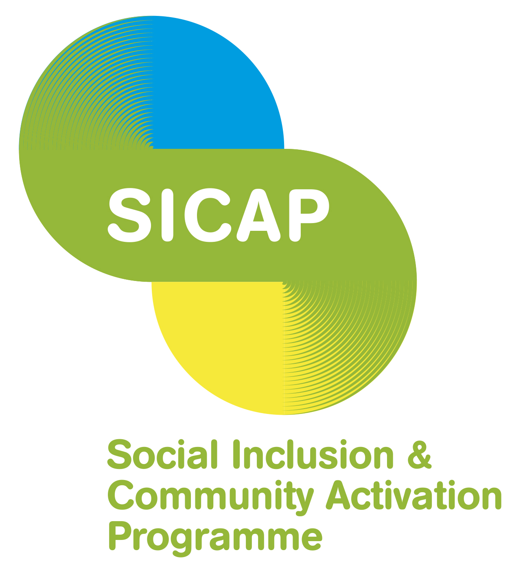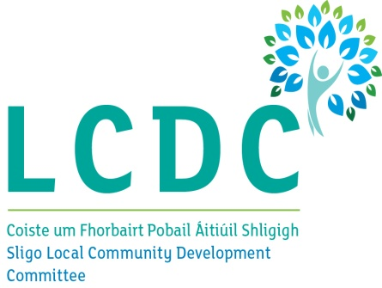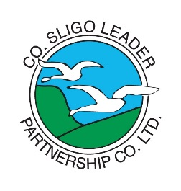

A short confidential survey of where communities are at and the help you need. This builds on an earlier 2020 survey assessing community group need through the PPN network.
So that we can learn more about your work and then help each other more.

Organisation name
Email and mobile
Contact person

- Main activities in 2019/2020

Please outline your main activities in 2019/2020 (e.g. projects, courses, events, developments etc.)

- Positive impact

Mention three positive impacts your organization has had on your target area/people.
Target area/group | Description of positive impact

- Priorities/opportunities 2021

Describe your main priorities or opportunities you see for 2021.

- Support
What type/areas of support do you most need to assist you in achieving your plans for 2021 and beyond? E.g. training, policies development, legislation, shared facilities, financial support etc.
Area | Type of support

Thank you
Please return to: eharan@sligoleader.com by Wednesday 3rd of March 2021

