

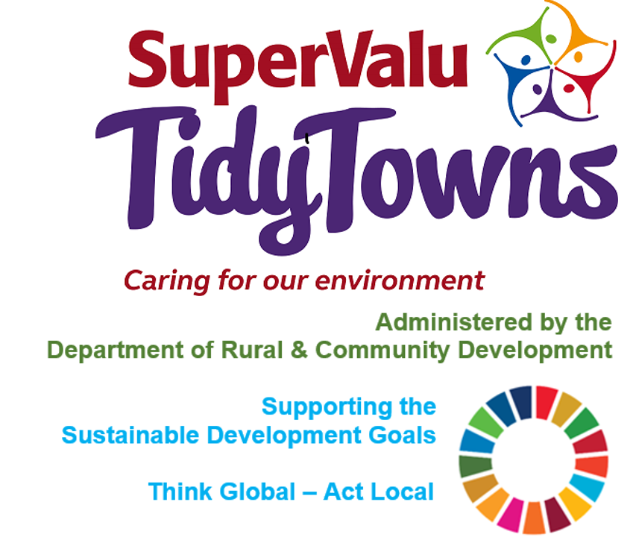

**Pobal**

[tidytowns@pobal.ie](mailto:tidytowns@pobal.ie)

<https://www.facebook.com/OfficialSuperValuTidyTowns>



[Description: Description: Description: https://encrypted-tbn2.gstatic.com/images?q=tbn:ANd9GcTn6e_yvEEKZGqngkOvFQKXiE5grEl9MBv8f3BIJGAnDVia4IA6BMWDw64](https://www.google.ie/url?q=https://about.twitter.com/press/brand-assets&sa=U&ei=gIVOU7azCeed7Qafq4DoCw&ved=0CC4Q9QEwAQ&sig2=_2Ys344bv7jS9rXT1Izm4w&usg=AFQjCNEMyI7-tFvyJYa1KkCdXm5XILcS9g)   <https://twitter.com/TidyTownsIre>



<https://www.tidytowns.ie>

**Tidytown email**

[tidytowns@drcd.gov.ie](mailto:tidytowns@drcd.gov.ie)

**Webinar**

[Limerick European Green Leaf](https://scanner.topsec.com/?u=https%3A%2F%2Fwww.youtube.com%2Fchannel%2FUCs0ZcWQQcOoQzTS7fb-LwYg%3Fview_as%3Dsubscriber&t=8492b47935c1e4fe674c32e419b461fe4d4f12c9&d=1377&r=None)

**Tree Project**

<https://kildare-nationalist.ie/2021/02/16/bringing-communities-together-through-trees/>

<https://kildare-nationalist.ie/2020/02/04/orchard-scheme-gets-kildare-kids-planting-trees/>

<https://www.easytreesie.com/>

<https://ewb-ireland.org/>

<https://crann.ie/>

**Sustainable Development Goals**

<https://sustainabledevelopment.un.org/post2015/transformingourworld/publication>

**Newsletter**

https://www.tidytowns.ie/about-us/newsletters/