

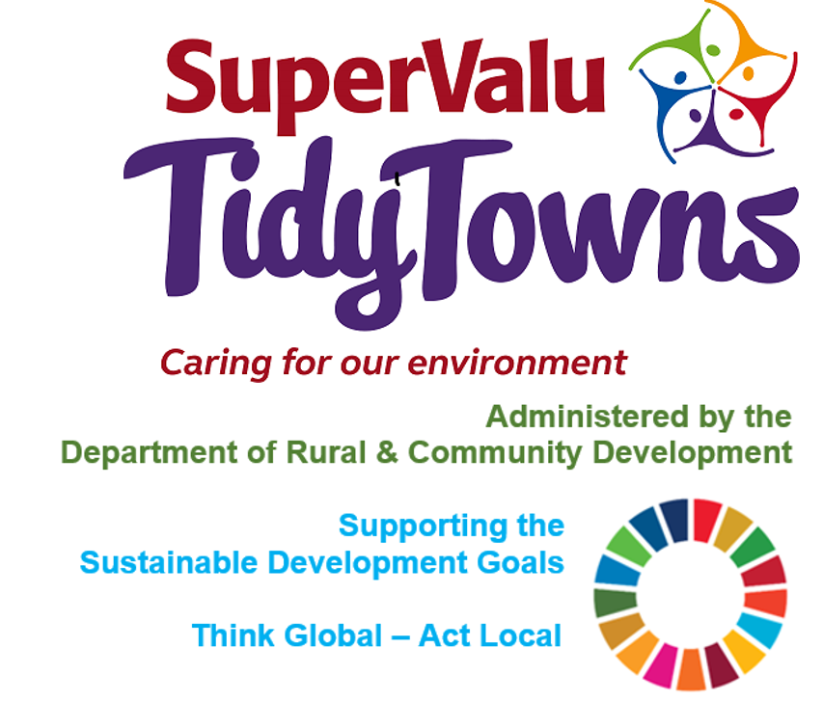

<https://www.facebook.com/OfficialSuperValuTidyTowns>



[Description: Description: Description: https://encrypted-tbn2.gstatic.com/images?q=tbn:ANd9GcTn6e_yvEEKZGqngkOvFQKXiE5grEl9MBv8f3BIJGAnDVia4IA6BMWDw64](https://www.google.ie/url?q=https://about.twitter.com/press/brand-assets&sa=U&ei=gIVOU7azCeed7Qafq4DoCw&ved=0CC4Q9QEwAQ&sig2=_2Ys344bv7jS9rXT1Izm4w&usg=AFQjCNEMyI7-tFvyJYa1KkCdXm5XILcS9g)   <https://twitter.com/TidyTownsIre>



<https://www.tidytowns.ie>

**Tidytown email**

[tidytowns@drcd.gov.ie](mailto:tidytowns@drcd.gov.ie)

**Webinar**

[Limerick European Green Leaf](https://scanner.topsec.com/?u=https%3A%2F%2Fwww.youtube.com%2Fchannel%2FUCs0ZcWQQcOoQzTS7fb-LwYg%3Fview_as%3Dsubscriber&t=8492b47935c1e4fe674c32e419b461fe4d4f12c9&d=1377&r=None)

**Sustainable Development Goals**

<https://sustainabledevelopment.un.org/post2015/transformingourworld/publication>

<https://sdgs.un.org/goals>

<https://irelandsdg.geohive.ie/>



**Newsletter**

https://www.tidytowns.ie/about-us/newsletters/

**All Ireland Pollinator**

[www.pollinators.ie](http://www.pollinators.ie).

<https://pollinators.ie/wp-content/uploads/2021/03/All-Ireland-Pollinator-Plan-2021-2025-WEB.pdf>

**Cobh TidyTowns**

[www.cobhtidytowns.com](http://www.cobhtidytowns.com)

**Tree Week**

<https://www.facebook.com/watch/?v=205967931325193>

**Kilbride TidyTowns**

<https://m.facebook.com/kilbridetidytowns/>

**Clár Funding**

[clar@drcd.gov.ie](mailto:clar@drcd.gov.ie)

<https://www.gov.ie/en/organisation/department-of-rural-and-community-development/>

**Look after yourself**

[www.hse.ie/healthandwellbeing](http://www.hse.ie/healthandwellbeing)

[www.healthyireland.ie](http://www.healthyireland.ie)

**Ringsend TidyTowns**

<https://www.facebook.com/margaret.dunne.39/videos/3004845832929636>

**Ensure your entry is received and registered**

<https://www.tidytowns.ie/competition/registered-entries/>

**The use of Pesticides/Herbicides**

<https://www.pcs.agriculture.gov.ie/media/pesticides/content/sud/ResponsiblePesticideUsePublicAmenityGardenAreas200217.pdf>

**Shaping New Mountains- Irish Wildlife Trust**

[www.iwt.ie](http://www.iwt.ie)

<https://iwt.ie/shaping-new-mountains/>

**Project Us**

<https://admin.concern.net/sites/default/files/documents/2020-10/1%20ProjectUs_Web.pdf>