

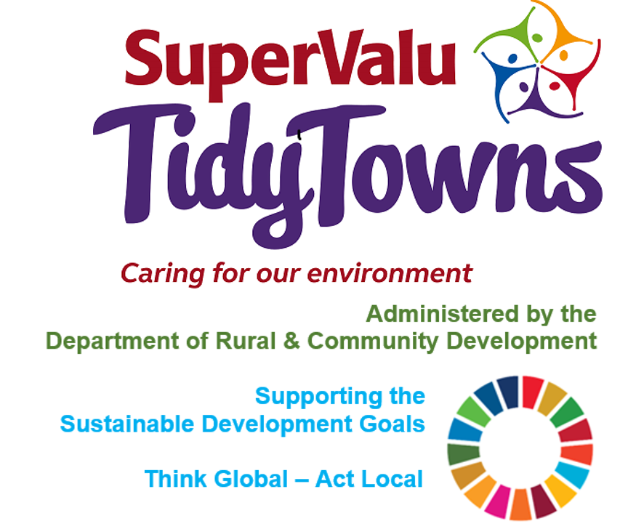

<https://www.facebook.com/OfficialSuperValuTidyTowns>



[Description: Description: Description: https://encrypted-tbn2.gstatic.com/images?q=tbn:ANd9GcTn6e_yvEEKZGqngkOvFQKXiE5grEl9MBv8f3BIJGAnDVia4IA6BMWDw64](https://www.google.ie/url?q=https://about.twitter.com/press/brand-assets&sa=U&ei=gIVOU7azCeed7Qafq4DoCw&ved=0CC4Q9QEwAQ&sig2=_2Ys344bv7jS9rXT1Izm4w&usg=AFQjCNEMyI7-tFvyJYa1KkCdXm5XILcS9g)   <https://twitter.com/TidyTownsIre>



<https://www.tidytowns.ie>

**Tidytown email**

[tidytowns@drcd.gov.ie](mailto:tidytowns@drcd.gov.ie)

**Newsletter**

https://www.tidytowns.ie/about-us/newsletters/

**Our Rural Future**

<https://www.gov.ie/en/publication/4c236-our-rural-future-vision-and-policy-context/>

**Castlebar TidyTowns**

[www.facebook.com/ConnaughtTelegraph/videos/444078923331255](http://www.facebook.com/ConnaughtTelegraph/videos/444078923331255)

**TidyTowns Survey**

<https://www.tidytowns.ie/reports/>

<https://supervalushoptalk.eu.qualtrics.com/jfe/form/SV_78JSPXEk6BZ9uh8>

**Newsletter**

https://www.tidytowns.ie/about-us/newsletters/

**Ballyduff TidyTowns**

[ballydufftidytodwns@gmail.com](mailto:ballydufftidytodwns@gmail.com)

**Circular Economy**

<http://circularliving.ie>

**Road Safety**

[www.rsa.ie](http://www.rsa.ie)

[cmangan@rsa.ie](mailto:cmangan@rsa.ie)

**Heritage Council**

[https://eventcomms.ie/cso.html](https://linkscan.io/scan/ux/aHR0cHM6Ly9ldmVudGNvbW1zLmllL2Nzby5odG1s/96B55DC22246C63F31E844FCC7A75B54B58569AF404E1E9EF39C5EB3D7453945?c=5&i=1&docs=1)

**Keadue TidyTowns**

**http://www.ocarolanharpfestival.ie**