

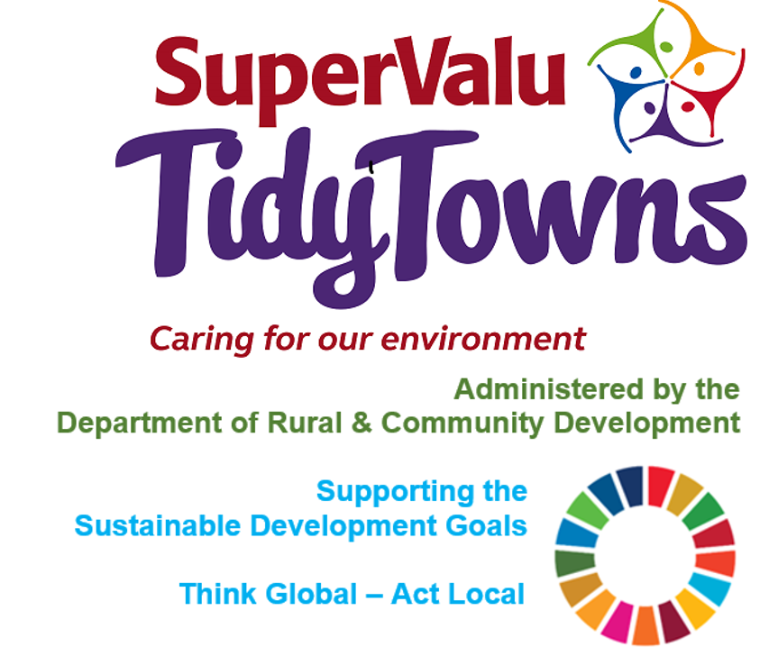

<https://www.facebook.com/OfficialSuperValuTidyTowns>



[Description: Description: Description: https://encrypted-tbn2.gstatic.com/images?q=tbn:ANd9GcTn6e_yvEEKZGqngkOvFQKXiE5grEl9MBv8f3BIJGAnDVia4IA6BMWDw64](https://www.google.ie/url?q=https://about.twitter.com/press/brand-assets&sa=U&ei=gIVOU7azCeed7Qafq4DoCw&ved=0CC4Q9QEwAQ&sig2=_2Ys344bv7jS9rXT1Izm4w&usg=AFQjCNEMyI7-tFvyJYa1KkCdXm5XILcS9g)   <https://twitter.com/TidyTownsIre>



<https://www.tidytowns.ie>

**Tidytown email**

[tidytowns@drcd.gov.ie](mailto:tidytowns@drcd.gov.ie)

**Newsletter**

<https://www.tidytowns.ie/about-us/newsletters/>.

**Registered Applications**

<https://www.tidytowns.ie/competition/registered-entries>

**Bat Conservation Ireland & University College Dublin’s Batlab**

[www.batsandbugs.ie](http://www.batsandbugs.ie)

**Eco Friendly project – Harper’s Island Wetlands**

<https://youtu.be/I0wjrv6ruZs>.

**Protect Our Past – OPW**

[https://issuu.com/obair/docs/protecting_our_past](https://issuu.com/obair/docs/protecting_our_past?fbclid=IwAR0NcgUBMP0v9ZU-QbFGjZTnTN6Uow_HpzWFgR30Qx-Q_TsccgZjgnwrSV4)

[www.gov.ie/opw/](http://www.gov.ie/opw/)

**Tuam TidyTowns**

<https://www.catchments.ie/tuam-tidy-towns-tells-the-story-of-the-river-nanny/>

**Rush TidyTowns unveil the Ros-Eó Mural**

<https://www.youtube.com/watch?v=O0Bv_z4bcf8>