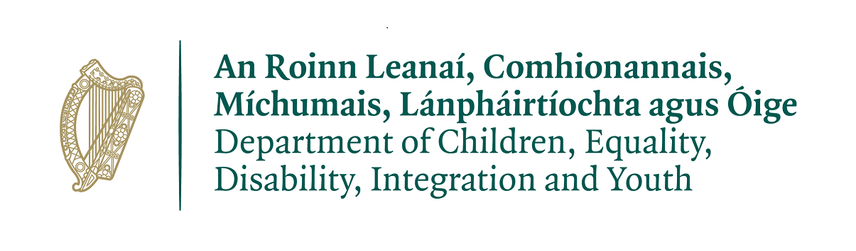
Targeted Youth Employability Support Initiative 2021/2022

Application Form

APPPLICATION DEADLINE:
12 noon, Friday, 24th September 2021
Please submit to:
youthwork@msletb.ie

Please note:
Only eligible Applicant Organisations should apply to this initiative.
Please ensure you complete every section of the form, DO NOT leave any section blank.
Please state N/A or NON APPLICABLE in sections not relevant to your application.
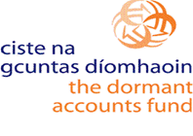
This Initiative is supported by Dormant Accounts Funding
Introduction
The Department of Children, Equality, Disability, Integration and Youth (DCEDIY) and [your Education and Training Board] or [ETB Name] are requesting applications to provide supports to young people on a Targeted Youth Employability Support Initiative.
The Initiative is open to community, voluntary and not-for-profit services and organisations that support young persons to access education, training or employment. Applications may be made by individual organisations. Joint applications are permissible, where a joint initiative is proposed, a lead organisation must be nominated as the responsible party for the application and all aspects of the Initiative.
All applications will be made through your local ETB. Recommendations will be made to the Department and the final decisions will be made by the Minister for Children, Equality, Disability, Integration and Youth and, with respect to the Dormant Accounts Fund, the Minister for Rural and Community Development.
- Please read the guidance note carefully.
- All applicants must give due attention to the needs and cohorts identified, many of whom will not be suitable for engagement in standard programmatic projects currently available.
- Where provided by the ETB, applicants must respond to the ETB TYESI Needs Profile.
- If you are unsure as to any aspect of the application process, please contact your local ETB youth officer.

Please submit your application in good time. The application time and date is:
12 noon, Friday, 24th September 2021
Please submit to: youthwork@msletb.ie
Applications received after this date cannot be accepted.
INCOMPLETE APPLICATIONS WILL CAUSE A DELAY AND MAY RESULT IN YOUR APPLICATION NOT BEING PROCESSED.

Guidelines for Applicants
Applicants are asked to note:
- Applications are to be provided to the ETB in electronic format and may be shared by the ETB with the Department when requested.
- It is the responsibility of the applicant to submit a completed application form. ETBs will not consider applications that are incomplete.

IMPORTANT NOTES
- Grants awarded must be fully spent within the year of allocation.
- The applicant’s Tax Clearance Access Code must be submitted with the application.
- Applications should only be submitted for funding of projects which can be fully completed, vouched and accounted for by the end of respective years of 2021 & 2022. Please note that unused funding from 2021 cannot be carried over to 2022 and must be surrendered to the administering ETB
- The maximum funding allocation per individual project will not exceed the allocation available to the ETB or €60,000 whichever is the lesser amount.
- Any money unspent by a grantee by December 31st 2021 and December 31st 2022 must be surrendered to the administering ETB. The Department and/or the ETB will recover money from any grantee found in breach of this requirement.
- Information provided is subject to the Freedom of Information Act 2014 and the Data Protection Act 2018.

PLEASE CHECK
The application must be signed by the chairperson or CEO of the organisation or the lead organisation if it is a joint application.
Please do not leave sections blank.
Please state NOT APPLICABLE in sections not relevant to your application.
INCOMPLETE APPLICATIONS WILL CAUSE A DELAY AND MAY RESULT IN YOUR APPLICATION NOT BEING PROCESSED

Application Form
Section 1 – Applicant Organisation Information
Applicant Organisation Details
  - Name of Organisation:

Please provide U.I.D. if the applicant is funded under UBU Your Place Your Space:

  - Address:

  - Affiliation to National Youth Organisation? Choose an item.
1.5 ETB Area: Mayo, Sligo & Leitrim ETB
Details of Contact Person
  - Contact Person:
  - Role:
  - Address:

2.4 Email: |  | 2.5 Telephone
3. DCEDIY Funding Allocated to Applicant Organisation in 2021
3.1 DCEDIY Funding:  - UBU Your Place Your Space  - Youth Information Centres |  |  | - €  - €
4. Tax Clearance (Please attach details of your current Tax Clearance Access with this application
4.1 Tax Reference Number:
4.2 Tax Clearance Access Number:
4.3 CHY Number (if applicable):
5. Bank Details
5. Are your current and up to date bank details held by the ETB? Yes ☐ No ☐
If Yes, please indicate N/A for the rest of the bank details section.
5.1 Name of Bank:
5.2 Address of Bank:

5.3 IBAN:
Section 3 – Financial Details
Financial Details
6.1 Cost of Overall Project: |  |  | €
6.2 Grant Request (the grant amount sought) |  |  | €
6.3 Have you received funding for the subject of this application from another source? |  |  | Yes ☐ No ☐
6.4 If yes, please indicate the source(s) of this funding:

6.3 If the total cost of the application is greater than the amount of the grant sought, please outline where and how the balance of funding will be secured and how this will avoid duplication or displacement of Exchequer funding:

Section 3 – Proposal
A minimum score of 75 marks will be required for further consideration and prioritisation by the ETB Co-ordination Group. In completing this section please consider the following headings that will be used to evaluate your complete application:

- Identified need (Mandatory: Pass/Fail);
- Progression through Partnership (30);
- Soft Skills (Approach) (30);
- Additionality and Sustainability (30);
- Mentoring and Coaching (30); and
- Value for Money (30).

The format of the proposal is to be followed. Recognition of the affect of Covid-19 restrictions, while not a focus, may be considered.

Proposal Details
7.1 Summary statement of proposal to address identified needs, including any identified by the ETB, and the aims/ objectives of this Initiative (max 200 words):

7.2 Please provide a synopsis of the target group and geographic area to be addressed in this application (include number of young people, age profile, estimated duration of the programme or action, and estimated contact hours with young people) (max 200 words):

7.3 Please provide information demonstrating how the applicant intends to meet the needs of the target group(s) referred to in the guidance document and/or as specified by the ETB, and how it is intended to engage with hard-to-reach young people (max 200 words):

7.4 Outline the soft skills the applicant organisation intends to focus on developing with the young people in the target groups (max 200 words):

7.5a Please clarify what pathways through partnership have been identified for young people and how this progression will be implemented (max 200 words):

7.5b Please provide information on the input of young people during the lifetime of the project (max 100 words):

7.6 Please describe how the proposed activities are additional to those already provided by the organisation, and also indicate the organisation’s capacity to deliver the service outlined (max 200 words):

7.7 Please outline whether a mentoring and coaching approach has been incorporated into the delivery of the service, demonstrating how it will work (max 200 words):

7.8 Please provide information on how this application represents value for money and indicate what steps the applicant has taken/is taking to ensure avoiding duplication with existing services in the area (max 200 words):

Section 4 – Profile of Expenditure/Project Budget
Please complete the following template: a profile of estimated expenditure on the basis of a full year of the Initiative. (The maximum funding allocation per individual project will not exceed the allocation available to the ETB or €60,000 whichever is the lesser amount).
Targeted Youth Employability Support Initiative – Estimated Budget for One Year
Direct costs: |  | Please give a short rationale for costs
Staffing costs: | €
Salaries including Employers PRSI | €
Staff recruitment costs | €
Staff travel and subsistence costs | €
Staff direct telephone costs | €
Total: | €
Programme costs:
Venue hire | €
Course/training materials | €
Tutor/facilitator costs | €
Adverting and publicity costs | €
Design and printing costs | €
Website costs - specific to the project | €
Equipment – small project items | €
Other: Please specify | €
Item 1: | €
Item 2: | €
Item 3: | €
Total:
*Indirect overhead costs: | €
Item 1: | €
Item 2: | €
Total: | €
Total cost of project: | €
*indirect costs refer to rent, light heat etc. – these can be no more than 10% of the application.
Section 5 – Declaration
On behalf of the organisation named at 1.1 above, we apply for a once-off grant for the purpose stated above and declare that the information given in this application is true and complete to the best of our knowledge and belief. We consent to DCEDIY or the relevant ETB making enquiries to a third party if necessary regarding details of the funding application.

We understand that information supplied in or accompanying this application may be made available on request under the Freedom of Information Acts 1997 and 2003 or under the 2018 EU General Date Protection Regulation. We also understand that making this application does not guarantee that funding will be granted.

We also accept that, as a condition for the award of a grant, no commitment has been made by DCEDIY, Mayo, Sligo and Leitrim ETB or any other statutory body, to the awarding of other grants. The project sponsors are agreeable to have the project monitored by Mayo, Sligo and Leitrim ETB or its agents on behalf of the DCEDIY and to allow access to its premises and records, as necessary, for that purpose.
If funding is approved, we agree and confirm that we will manage the grant in accordance with the conditions. We agree to seek value for money and to abide by the Public Procurement guidelines. The funds will be applied for the purposes set out in the application and we undertake that funding from any other source will not be used for the same purpose. In the event that we are unable to spend the grant for the purposes set out in our application, we agree to return unspent monies to the ETB. We understand that the Department of Children, Equality, Disability, Integration and Youth or Mayo, Sligo and Leitrim ETB may seek the refund of the grant if we fail to comply with these conditions.

We acknowledge that any funds awarded are subject to such funds being available to the Department of Children, Equality, Disability, Integration and Youth and that they must be used in 2021/2022 and for the purpose stated and not to replace existing funding and we will acknowledge the support we have received from the Department of Children, Equality, Disability, Integration and Youth and the Dormant Accounts Fund in all publicity relating to the project.

We hereby apply for grant funding and accept the above Terms and Conditions:

Signed: ___________________________________ (CEO or Chairperson)

Position: ___________________________________

Date: ___________________________________

