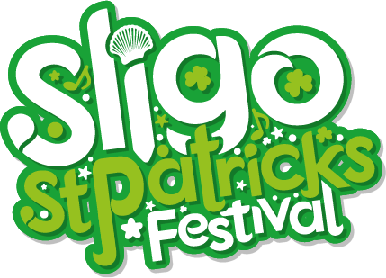

**St. Patrick's Day Sligo - 2022 Application Form**

In order to make an entry into the parade, you must complete the following. Please give as much information as possible about your entry. Sections marked * are required. If saving the file as a document, leave an X to the right of your answers.

Company/Group name * ___________________________

Contact Name * ___________________________

Address * ___________________________

Contact number * ___________________________

Email address * ___________________________

Description of entry * Float Walking Vehicle Other:

Detailed description of entry *

(Tell us more about your entry ie: size of float or number of people):

Additional information (Anything else you feel you need to let us know):

Vehicle entry * It's your responsibility to ensure your vehicle is fully road-worthy.

Please tick if you have following:

Insurance: Tax: NCT:

Driving licence: N/A: Other:

Participants are responsible for carrying out their own assessment on their entry.

All special needs and requirements are the sole responsibility of the entrant. *

I agree I do not agree

Participants are responsible for following the Health & Safety Rule of the parade. *

I agree I do not agree

Do you agree to the Terms and Conditions of Parade Entry? *

I agree I do not agree