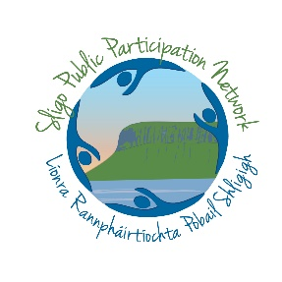
Sligo PPN

Community Representatives Reporting Template

Pat Benson and Connie Nell
PPN Rep Name | Brendan Lynch
Committee Name | LCDC/LAG
Date of Meeting | 24/02/22

Other Reps who fed into this Report
(if applicable)

Date of next meeting | April 7th 2022 | Signed (PPN Representative) | 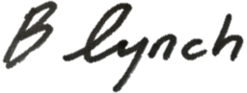
This meeting involved assessment of and allocation of budgets, updates on projects, and new funding applications. The PPN Reps raised the need for projects to be assessed through the goals of SDG’s and a Green Sligo within the Vision 2030. This was well received, and agreed by the committee. The PPN Reps also raised the need for supports and encouragement for groups, when making funding applications, to find ways of alligning with more environmentally sustainable best practices.
Sligo Leader Company invited Connie Nell, our Environmental Rep, to work with them, drawing on her experience and knowledge regarding environmental issues and best practices, along with her ideas regarding ways of meeting the environmental challenges before us. The PPN Reps brought attention to the upcoming PPN elections. There is an election for the Sligo Age Friendly Alliance, and two positions free on the Secretariat. We encouraged members of the committee to raise awareness of these among the community groups they are involved in and connected with.

