

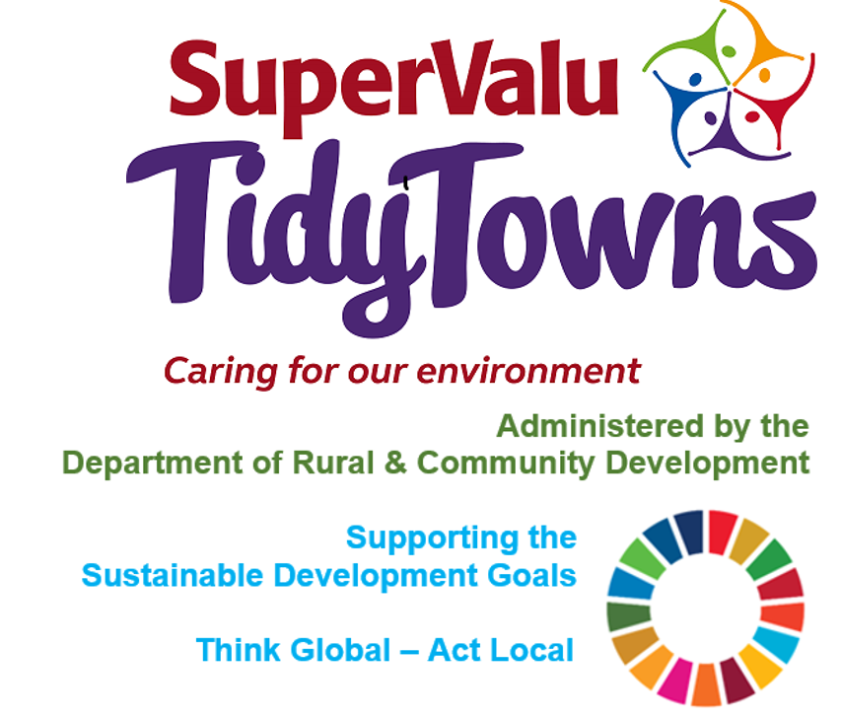

<https://www.facebook.com/OfficialSuperValuTidyTowns>



[Description: Description: Description: https://encrypted-tbn2.gstatic.com/images?q=tbn:ANd9GcTn6e_yvEEKZGqngkOvFQKXiE5grEl9MBv8f3BIJGAnDVia4IA6BMWDw64](https://www.google.ie/url?q=https://about.twitter.com/press/brand-assets&sa=U&ei=gIVOU7azCeed7Qafq4DoCw&ved=0CC4Q9QEwAQ&sig2=_2Ys344bv7jS9rXT1Izm4w&usg=AFQjCNEMyI7-tFvyJYa1KkCdXm5XILcS9g)   <https://twitter.com/TidyTownsIre>



<https://www.tidytowns.ie>

**Tidytown email**

[tidytowns@drcd.gov.ie](mailto:tidytowns@drcd.gov.ie)

**Newsletter**

<https://www.tidytowns.ie/about-us/newsletters/>.

**Handbook**

<https://www.tidytowns.ie/competition/handbook/>

[www.supervalu.ie](http://www.supervalu.ie/)

**Sustainable Development Goals (SDG’s)**

<https://sustainabledevelopment.un.org/post2015/transformingourworld/publication>

<https://sdgs.un.org/goals>

<https://irelandsdg.geohive.ie/>

[www.tidytowns.ie/about-us/newsletters](http://www.tidytowns.ie/about-us/newsletters)