2022

Sligo Public Participation Network

January to November 2022

REPORT ON ACTIVITIES

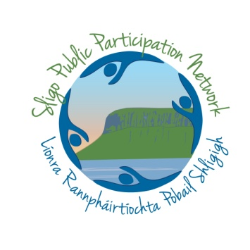

SLIGO PUBLIC PARTICIPATION NETWORK | November 2022

Contents

Introduction

Membership
Elections/Representation
Activity Reports
Other PPN Activities
Social Media/Communication
Operational Overview
2023 Plans

INTRODUCTION

The very ethos of Public Participation Networks is about bringing people together, engaging with our members, sharing voices and generating important discussions.

In this annual report summary we try to ensure that all our member groups are kept up to date on the work of the network, that you are aware of the members of the community acting in a representative capacity on your behalf.

There has been a lot of movement at national level regarding the operation of PPN networks, at the core a Structural Review of PPNs commissioned by the Department of Rural and Community Development. This report highlighted a number of issues and opportunities for the development of PPNs across Ireland and a working group has now been established to shape the development of the networks going forward. Sligo PPN are represented on this working group by Pippa Black, Social Inclusion Representative on Sligo PPN Secretariat. Regardless of these changes, the PPN continues to try and ensure that the public’s voice is represented at the decision-making level through supporting our representatives, making submissions with the input of our member groups and through our election processes. The PPN has also delivered a number of training and information sessions and have instigated a number of community focused projects.

If you have any questions or comments please contact 071 91 14430 / ppn@sligococo.ie.

MEMBERSHIP

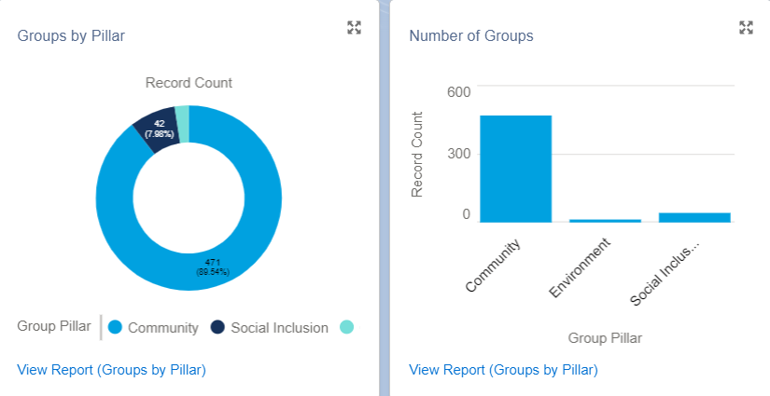
Sligo PPN currently has 536 member groups:
- Community & Voluntary Pillar 480 (89.55%)
- Environment Pillar 13 (2.4%)
- Social Inclusion 43 (8.02%)

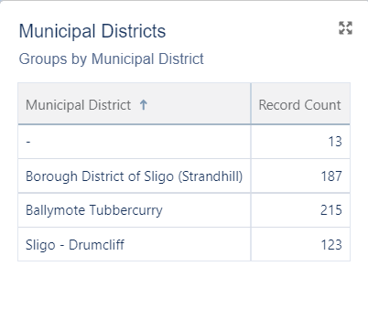

Other Election & Community Representation News

LOCAL
- PEACEPLUS – 4 Reps from Sligo PPN sought were sought in 2022 for the Social Partner pillar of the new PEACEPLUS partnership. 2 nominations are in and the call for the remaining 2 seats is open. All nominations will go to an assessment panel
- Public Arts Steering Committee – PASC – still open
- LCDC – Community Representative Jean Finnerty stepped down from her role as rep on Sligo LCDC and was replaced by Billy Gallagher from Cartron View Point Residents Association
NATIONAL / INTERNATIONAL
- PPN environment rep Joan Swift represented the network on the OECD panel for the discussion and launch of the new national report “Towards Irish transport systems that work for the people and planet”
- Pippa Black, Social inclusion rep on the Secretariat and SPC1 was elected to the National PPN Secretariat and the newly established Roadmap Implementation group, charged with the implementation of the recommendations in the Mazars report for structural change across PPNs
- The Sligo PPN Resource worker represents the national Resource Worker Network on the PPN National Advisory Committee (NAG). They have also been nominated to the Cross Sectoral committee for Community Development

Full Current PPN Representatives
(E) Environment College / (SI) Social Inclusion College / (CV) Community and Voluntary College
Sligo PPN Secretariat; Joan Swift (E), Michael Bell (E), Brendan Lynch (SI), Pippa Black (SI), Pat Benson (CV), Mark Kupczak (Ballymote Enniscrone MD), Lisa Moore (Sligo Strandhill MD).
Strategic Policy Committees (SPC)
There are 4 SPCs in Sligo County Council .Sligo PPN currently has 10 seats across the four Strategic Policy Committees for community representation.
SPC1 Housing & Corporate Alan McMenamin (SI), Pippa Black (CV), Melinda Swan (E)
SPC2 Environment and Infrastructure Sharon Eastwood (CV), Joan Swift (E)
SPC3Planning, Economic and Community Development, Arts and Culture Corena Ward (CV), Sheila Scanlon (SI), Emer Knowles (E)
SPC4 Climate Change Lisa Moore (CV), Yvonne Lang (E)

Local Community Development Committee : Brendan Lynch, Pat Benson, Connie Nell, Noelle O’Gara, Billy Gallagher
Sligo Sport and Recreation Partnership : Geraldine Delorey, Joe McDonagh,
Joint Policing Committee; Gail McGibbon, Vanessa Clark, David Tuffy, Eugene McCaffrey, Michael Collins, Sheila Leydon
Public Arts Steering Committee – currently out for election
PEACEPLUS Partnership – Still Open
Sligo Heritage Forum; Wendy Lyons, Angela Wallance, Robert Hensey
Sligo Place Names Committee; Padraig Meehan
Ukranian Community Response Forum; Sheila Scanlon
Independent Evaluation Committee; Sharon Boles, Lorna Curry
North West Fisheries Local Action Group; Mikey Kilcullen
ACTIVITY REPORTS

Ukrainian Community Response
Representatives of Sligo PPN are members of the Sligo Ukranian Community Response forum allowing the community sector to identify areas where they can support the integration of Ukranian people into the local community. The PPN worked closely with the FRC network around the county to put in place a series of Community interventions to help people transition to life as part of the Sligo community. Some of the key activities that took place through the FRC network included summer activity camps, English language lessons, cookery lessons and all focussed on supporting people to engage with community activities.
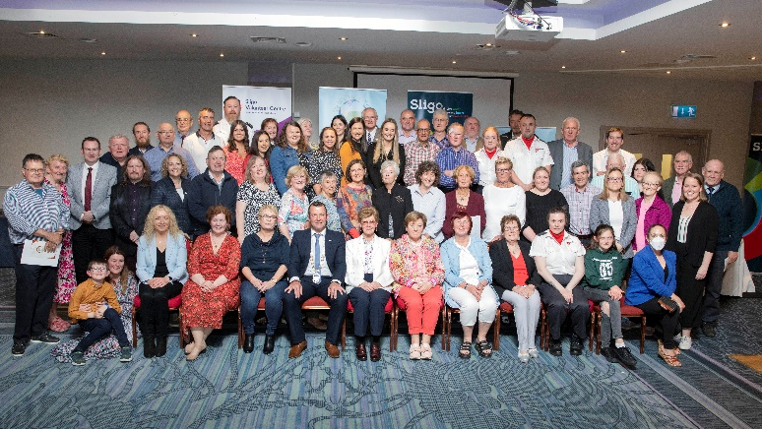
Community Celebration Event
Early in 2022, the Department of Rural and Community Development asked Local Authorities, Volunteer Centres and PPNs to organize a county event to acknowledge the effort of people who gave their time voluntarily during the pandemic to help others. In April, 2022 the Department opened a nomination process whereby groups that signed up to the COVID “Community Call” had the opportunity to nominate volunteers to receive an acknowledgement award for their effort i.e. a pin and a letter from the Taoiseach. In Sligo over 80 community and Voluntary Groups signed up to the community Call. An recognition ceremony took
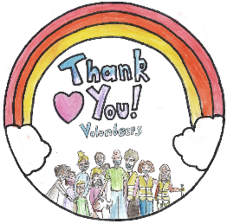
place in the Clayton Hotel on the 19th May which was attended by around 150 people.

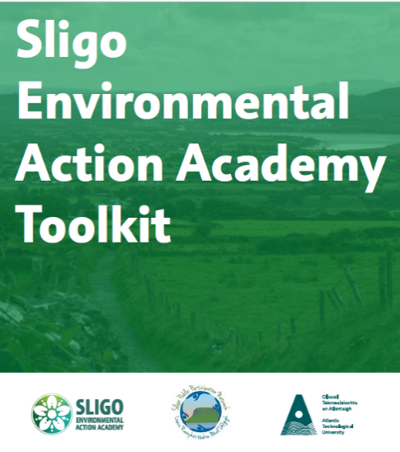
ATU - “Power to Change” is led by ATU in partnership with the Sligo Public Participation Network. The project will facilitate connection/reconnection with nature and build capacity within community groups to lead on change. A key focus of the project is to engage with groups that have been under-represented in the Climate Conversations and will be guided by the principles of universal design for research to ensure inclusivity and accessibility.
This project aims to generate materials to aid capacity building within community groups, and establish lasting connections and networks between ATU and community groups.

Environmental Action Academy toolkit
Based on a needs analysis with our member groups, the PPN set up the Environmental Action Academy. The first phase of this was a partnership with Sligo Environment Network who delivered a series of focus groups and mentoring sessions to explore with our members their key priorities relating to better environmental action. The findings from this process were then used to inform phase 2, our partnership with ATU Sligo which saw the development of the Environmental Action Academy Toolkit – a guide to support community organisations to improve the way they operate on a daily basis in terms of enhancing their environmental focus.
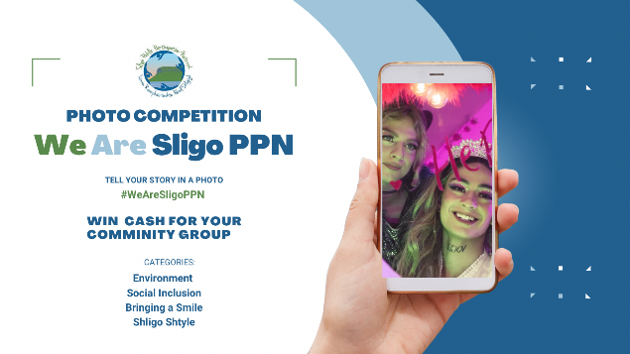
Photography Competition
In summer 2022, Sligo PPN launched our community photography competition. The aims behind the project were to;
- Highlight and promote the work of our member groups

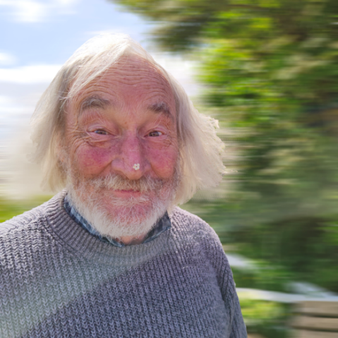
- Develop a suite of community images to be used across PPN publications and publicity
- To offer a small level of support to our members
Images were submitted under four main categories; Environmental Action, Celebrating Inclusion and Diversity, Bringing a Smile and Shligo Shtyle. There were also 2 additional special categories : Ministers Selection with Minister for State Joe O’Brien selecting his favourite image that celebrated community in Ireland and Chief Executives Choice with Sligo County Council CE Martin Lydon sponsoring and selecting the image that he felt best represented the unique community of Sligo.
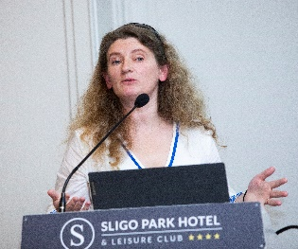
Rivers Trust Sligo
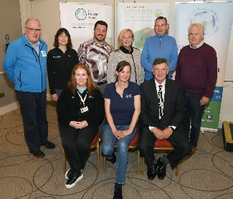
As part of the Sustainable Development Goals week, Sligo PPN worked with the The Rivers Trust and Local Authorities Water Programme to host an information evening aimed at exploring the option of establishment a Rivers Trust initiative in County Sligo. The event took place in the Sligo Park Hotel and participants heard from Constanze O’Toole and Mark Horton from The Rivers Trust, Trish Murphy from Inishowen Rivers Trust and Aisling Reilly, LAWPRO catchment scientist. The action was instigated by Secretariat member Pat Benson. The meeting was a great success and progress is now being made in officially establishing a Rivers Trust committee for the county.

PPN Community Outreach
We all acknowledge the pandemic has had a huge impact on the community sector and many groups struggled to reform. Sligo PPN undertook a programme of reaching out directly to every single member group to check on their status following re-opening. The process sought to confirm that groups are still in operation, to update contact details and to identify emerging needs and areas of support needed. Any information provided will be used in our 2023 planning.

Energy Clinic
Sligo PPN partnered with the Contact Research Unit in ATU to deliver information workshops to the community with regard to community energy and to guide groups and individuals as to how they can navigate available grants and schemes to improve their environmental footprint.

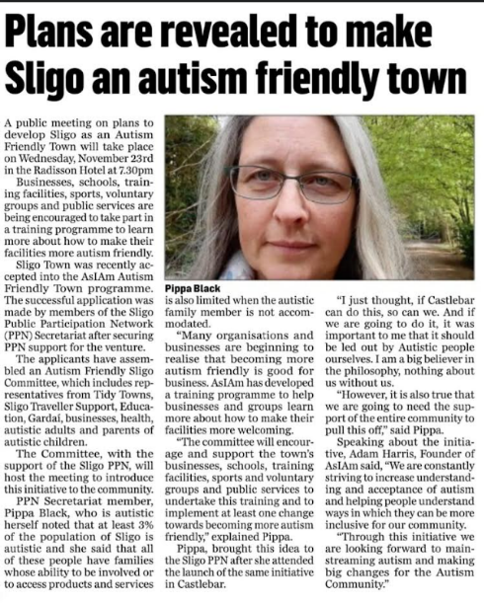
Autism Friendly Sligo
In 2022, the Social inclusion college of the PPN successfully applied for Sligo to be designated under the Autism Friendly Towns programme through AsIAm. Social inclusion representatives are currently working with local groups to develop the initiative and the first network meeting was held on the 23rd November in the Radisson Hotel.

Sligo PPN position on Housing
Housing – A community Policy. A newly established Housing Thematic Group within the PPN structure is bringing together a range of organisations and individuals who recognise housing as one of the social justice challenges of our time. The network will be partnering with Social Justice Ireland to research, consult and develop a series of community housing positions which reflect what the community of Sligo want to see in terms of a future of fair and affordable housing in the county. PPN representatives on key bodies such as the Strategic Policy Committee on Housing and the Local Community Development Committee will use these positions as they represent the voice of the Sligo Community at the decision making table.
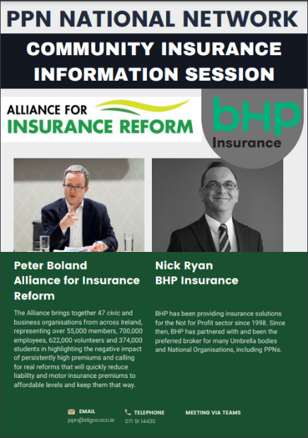
Insurance Seminar
The issue of community insurance is one that remains a priority for PPN member groups. Sligo PPN organised a national information session for all PPN groups across Ireland to hear from Peter Boland from the Alliance for Insurance Reform and Nick Ryan from BHP Insurance to both hear about the national direction the insurance sector is heading and to get advice on individual group needs.

‘A day in the Life’
The Social Inclusion representatives of Sligo PPN have begun an exciting new project which explores and highlights via social media the challenges experienced by those living with a disability or mobility issue in county Sligo in terms of accessing basic services and amenities. Working with a broad range of community sectors the PPN representatives will produce a number of short videos to highlight barriers and suggestions for action. As well as raising awareness, the representatives intend to use these visuals as a means to inform local policy development. Any members of the community interested in getting involved email the PPN secretariat on sligoppnsecretariat@gmail.com

Sligo Disabled Persons' Organisation (DPO)
As part of his work on the Sligo Disability Consultative Committee (DCC), PPN Representative Mark Kupczak identified that there was a lack of disabled representation with lived experience in County Sligo. Many of the existing DCC members representing disabled service providers are not disabled themselves and the majority of them are not resident in Sligo.

To address this and in conjunction with lecturer, Peter Kearns, who also works with the Independent Living Movement of Ireland (ILMI) and the support of the Sligo PPN Secretariat, Mark set to work bringing together interested parties to form a Sligo based DPO. A DPO is an organisation of all disabled members that lobbies for change using a rights based approach based on the UNCRPD, which was ratified in Ireland in 2018. The group applies the social model of disability, which recognises that people are disabled not by their impairments but by the lack of inclusion and provision within their communities.

The Sligo DPO held their first AGM on Wednesday 16 November where they elected a committee and adopted a Constitution. They are now in a position to apply to join the PPN as an associate member group and in six months would hope to join as full members.

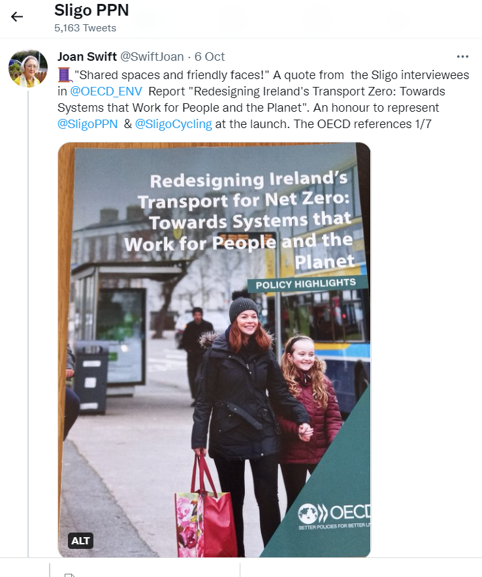
Redesigning Ireland’s Transport System for Net Zero
Sligo PPN was honoured to be invited to the recent launch of the OECD Environment Directorate report Redesigning Ireland’s Transport System for Net Zero:Towards systems that work for People and the Planet (2022) https://doi.org/10.1787/b798a4c1-en.The report was produced at the request of the Climate Advisory Council and it aims to show that as a society we can maintain wellbeing while reducing emissions.

Sligo’s involvement in the launch came as a result of prior engagement with OECD research which saw the authors visit the county and speak to PPN representatives about their vision for a sustainable transport system. The report references Sligo PPNs Vision for Community Wellbeing with the authors stating: ”The results of the public consultations informing the Sligo Vision for Wellbeing confirms that people consider the provision of access to schools, friends, places and services via sustainable modes as the main contribution that the transport sector can make to improve their lives The report also mentions the Sligo group came up with the slogan "Shared places and friendly faces"!

PPN representative Joan Swift was invited to be part of a 4 person panel to respond to the launch of the report on October 5th. The report recommends a participatory bottom-up approach to transforming our transport system. The PPN is very much a bottom up organisation so it was fitting that Joan represented our sector.

Climate Conversations
Sligo PPN were once again part of the initiative of the Department of Environment, Climate and Communications to generate a series of community consultations around climate change and environmental action. Findings from the consultations across the PPN network were compiled to create a national picture which informs the development and roll out of national initiatives around climate action. The consultation was led by Sligo PPN Environmental representatives.

The Dream For Our Land
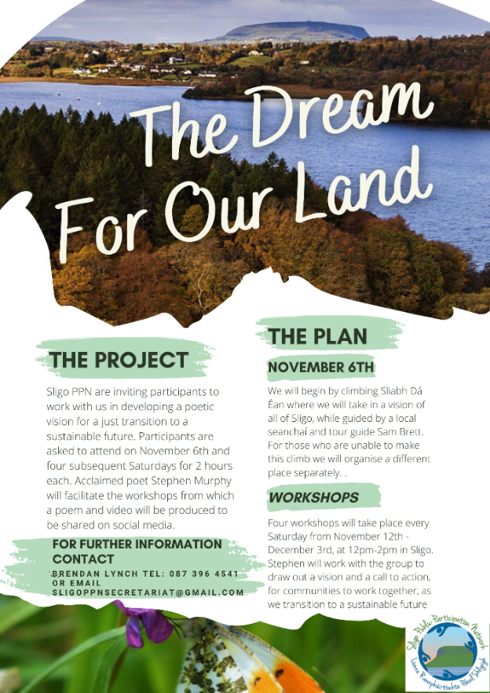
PPN Representatives are working with member groups to find out what Sligo means to the local community and what the collective vision is for the future of the local landscape for future generations. The project features exploration activities of the local area, focus groups and Vox Pops and will culminate in the creating of a poetic vision. The aim of the project is to raise awareness of what a sustainable Sligo might look like, to reconnect people with the local environment, to create a bank of information on what the community see as priorities for preservation and to engage communities in climate action.

Community Needs Analysis
This year the PPN is conducting the needs analysis process slightly differently, partnering with PPNs across the north west region to pilot a regional approach to community supports.
This year we have a collective survey that will be shared across the region and we will
develop our training and support calendar to maximise local resources and create new
opportunities for networking across the north west region.

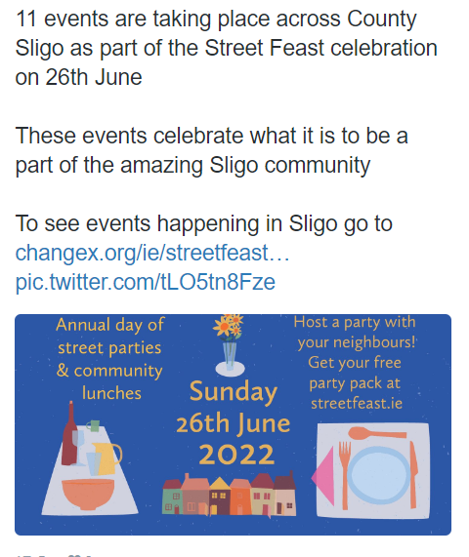
Street Feast
Sligo PPN supported Streat Feast 2022 which saw 11 community gatherings take place across Sligo on 26th June. The initiative centres on the use of sharing a meal to encourage neighbours to get together and re-engage.

Website
PPN representatives have been working to redesign the PPN website to make it more user friendly and accessible for the community sector

National Networking Activities

Sligo PPN were elected to represent the national PPN network on the National Advisory Group hosted by the Department of Community and Rural Development (DRCD) and Chaired by Principle Officer Ciara Bates. This group deals with the oversight of PPN operations and is currently charged with a national structural review of public participation in Ireland to inform how the networks will evolve into the future.

Sligo PPN also have a role on the recently formed DRCD national communications group which is charged with developing an overarching publicity campaign to raise the profile of PPNs across the country.

Alongside Kilkenny PPN, Sligo represent the PPN network on the Cross Sectoral Committee for Community Development

National Resource Worker meetings of the PPN take place every quarter to allow workers to share ideas, concerns and information. While normally held in Dublin, these have been taking place online

In additional to national meetings, North West Regional Meetings are also held every 2 months attended by resource workers and Secretariat representatives to allow for discussion around participation and engagement in the North West.

Pippa Black is the Sligo PPN Secretariat representative who sits on the National Secretariat Network and also the Roadmap Implementation group to shape the future development of PPNs.

OTHER PPN ACTIVITIES

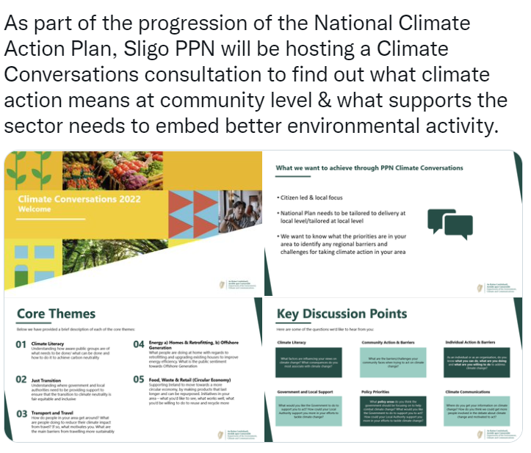
Training and Supports
- Health in the Community

Public Consultation & Submissions
- Sligo Vision 2030 / LECP
- Submissions to Mazars Review
- National Climate Action Plan

Reporting
- Ongoing reporting on PPN activities to Sligo Local Community Development
Committee
- Ongoing reporting to the management team of Sligo County Council
- Reporting to Department Of Rural and Community Development
- Production of Annual Report
- Reporting to Secretariat

Community Issues
- Active in the Alliance for Insurance Reform reflecting the view and issues from the
community sector

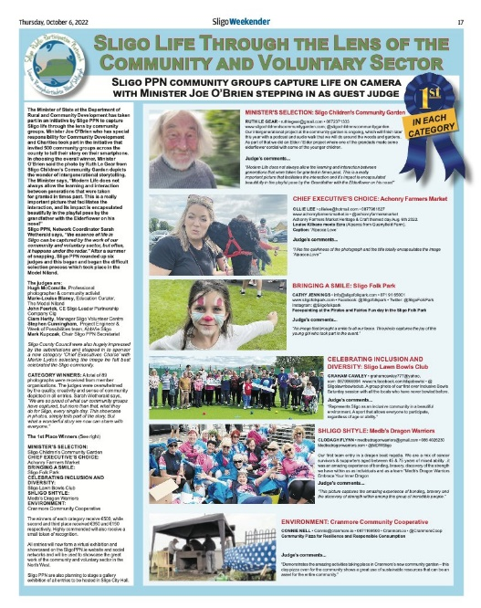
SOCIAL MEDIA AND COMMUNICATIONS

Sligo PPN has a growing social media profile and, especially across the March lockdown, we used our Facebook and Twitter accounts to make sure important information got out.

General Communications
- Promotion of member activities via PPN website, email
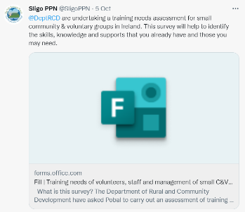
and social media platforms
- Production of quarterly Newsletter
- Notification to member groups with regard to opportunities for
informing strategy and policy development
- Promotion of all emerging funding rounds and circulars from Department of
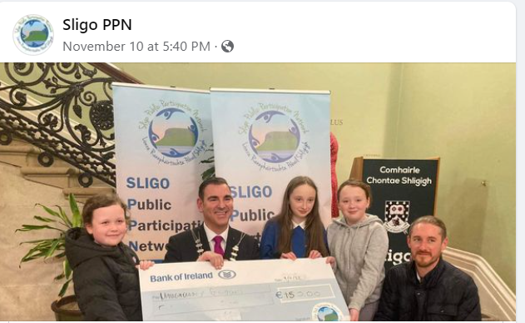
Rural and Community Development
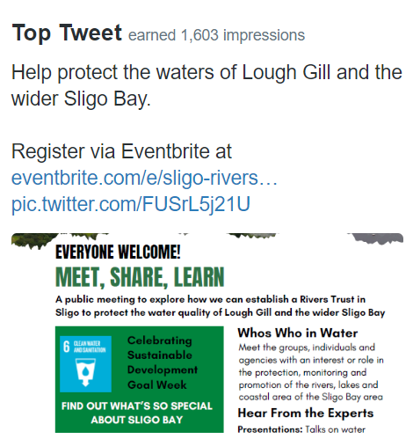
- Promotion of PPN activities and opportunities through traditional local media
We have over 1,600 Facebook followers

We average 35-40
Tweets per month

SUMMARY WORK OVERVIEW

Administration:
- Management of finances, banking and invoices
- Processed wages
- Produced ongoing reports to LCDC, Sligo County Council Management Team, Secretariat
- PPN elections
- Held pre-meetings with reps to aid preparation
- Held monthly secretariat meetings
- Ongoing reporting to the Department of Rural and Community Development

Communications:
- Circulation of grant schemes & event notices
- Six newsletters circulated by email and on social media
- Revamped website (newsletters, reps reports) and social media
- Promotional items in local newspapers
- Ongoing circulation of the Funding Digest

2023 PLANS & ACTIVITIES

To be completed follow closure of PPN needs analysis and Plenary feedback session

